Tel Aviv University

Workshop in Computational Analysis of Genomic Medical Data

Identifying Processes Leading to Metastases

Nevo Raz and Ofir Katz

April 2020

Table of Contents

Project Description 4

Dataset Description 5

Provided Datasets 5

1. TCGA Pre-processed Data 5

● Gene Expression Data 5

● Micro RNA Data 6

● Survival Data 6

● Clinical data for melanoma patients 7

2. GTEX Data 7

Additional Datasets Used To Complete Project 8

Main Methods Used 9

Hierarchical Clustering 9

What is clustering? 9

Hierarchical Clustering Methods: 9

How can we select a method to use? 9

Which packages will we use for the analysis? 9

PCA 9

What is PCA? 9

How can we select the number of principal components to use in our calculation? 10

Which packages will we use for the analysis? 10

Differential Expression Analysis 10

What is Differential Expression Analysis? 10

How do we define a highly-expressed/slightly-expressed gene? 10

Which packages will we use for the analysis? 11

Graph description: 11

Data Analysis Description 12

Section 1: 12

Question 12

Analysis Description 12

Main Visualizations 13

Conclusion: 21

Section 2: 22

Question 22

Analysis Description 22

Relevant Visualizations - Genes 23

Relevant Visualizations – Micro RNA 34

Conclusion 46

Section 3: 47

Question 47

Answer 47

Section 4: 48

Question 48

Analysis Description 48

Relevant Visualizations Part 1 49

Relevant Visualizations Part 2 52

Conclusion 54

Section 5: 55

Question 55

Analysis Description 55

Visualizations 55

Conclusion 57

Section 6: 59

Question 59

Analysis Description 59

Visualizations 59

Conclusion 61

Section 7: 63

Question 63

Analysis Description 63

Visualisations 63

Conclusion 64

# Project Description

In this project, we will examine data of patients with melanoma primary tumors and metastases. We will attempt to learn about and characterize the processes that lead a patient with a primary tumor to develop various types of metastases by trying to pinpoint specific genes and micro RNAs that are have similar a behavior in different kinds of samples. We will also compare samples of patients with melanoma to healthy skin samples in order to search for genes whose high expression in a sample may suggest the existence of a tumor.

This document contains seven main sections. This project explores several questions using gene and micro RNA expression data. In each section, we define a question regarding primary tumors and metastases that can be answered using our data, describe an analysis process we created to answer that question, and offer our conclusion from this process. The datasets used in this analysis come from public medical databases. The questions are also listed in the bottom of this page.

We relied on different methods and learned the basics of machine learning to draw our conclusions. We will take this opportunity to remind that the project was conducted by computer science and geophysics students with no prior background in medicine or cell biology. This exercise enabled a deeper learning and exploration of data science tools and about basic gene biology and processes in cancerous cells.

**Questions:**

1. If we look at gene expression data of primary tumors and metastases together, is there a clear distinction between them? Does such a distinction exist for micro RNA?
2. a) Which genes and miRNA have a higher expression in local skin metastases vs primary tumor? b) Which genes and miRNA have a higher expression in distant metastases? c) Which genes and miRNA have a higher expression in lymph nodes? d) Are the genes in the various organs similar?
3. What are the biological roles of the highly expressed genes in the various metastasis?
4. Which genes have a higher expression in tumors vs healthy skin? Are these genes similar to genes more highly expressed in metastases vs primary tumors?
5. There are miRNAs for which we know what genes expressions they affect. Are miRNAs that act differently between primary tumors and metastases known to be responsible for genes expressed differently between primary tumors and metastases? To answer this question, we should use external DBs that map known relationships between miRNA and genes, such as <http://www.mirdb.org/faq.html>
6. Among the genes and miRNA that are highly expressed in metastases vs primary tumors, are there genes/miRNA that affect the prognosis of the patient?
7. It is possible that highly-expressed genes for metastases will be related to the immune system, because the tumor may be larger and therefore the immune system may attack it more. Try removing such genes from your analysis

# Dataset Description

## Provided Datasets

For this project, we used two main sources that were provided for us to create our datasets: TCGA preprocessed data and GTEX data. We created two dictionaries to store our datasets: dataframes where we stored our main datasets and normalized datasets, and not_normalized_dataframes where we stored our dataset values without normalization (for gene expression data, micro rna data and gtex data only).

### **1. TCGA Pre-processed Data**

Downloaded data from the SKCM category included the following datasets for samples with melanoma (primary tumors and metastases, the naming convention is that samples of tumors end in ‘01’ and samples of metastases end in ‘06’). The original files were converted to csv and imported with pandas.

* **Gene Expression Data** (file titled “exp”):

**Dataset Description:** The dataset includes genes as rows and samples of primary tumors (ending in ‘01’) and metastases (ending in ‘06’) as columns. The data values represent counts of gene expression in the samples (with a minimum value of 0). Most gene names are formatted as **“gene name”.”gene NCBI id”**.

**Cleaning the Data:** Irrelevant gene rows were removed from the dataset (starting with ‘X..’) and irrelevant sample columns were removed from the dataset (ending in ’07’, ‘11’).

**Data Shape:** The dataset includes 19363 genes and 471 samples (103 primary samples and 368 metastases samples).

We converted this data into two datasets:

* + **dataframes[‘gene_data’]:** a normalized dataset with 10650 genes and 471 samples created by:

performing log2(val + 1) to counts

removing features (genes) with low variance (we chose to remove values with variance below the 45th percentile)

per gene value, subtracting the row mean (gene mean) and dividing by row std (gene std), resulting in a mean of 0 per row and std of 1.

* + **not_normalized_dataframes[‘gene_data’]:** the original data (after cleaning) without normalization, containing 19363 rows (genes) and 471 samples.

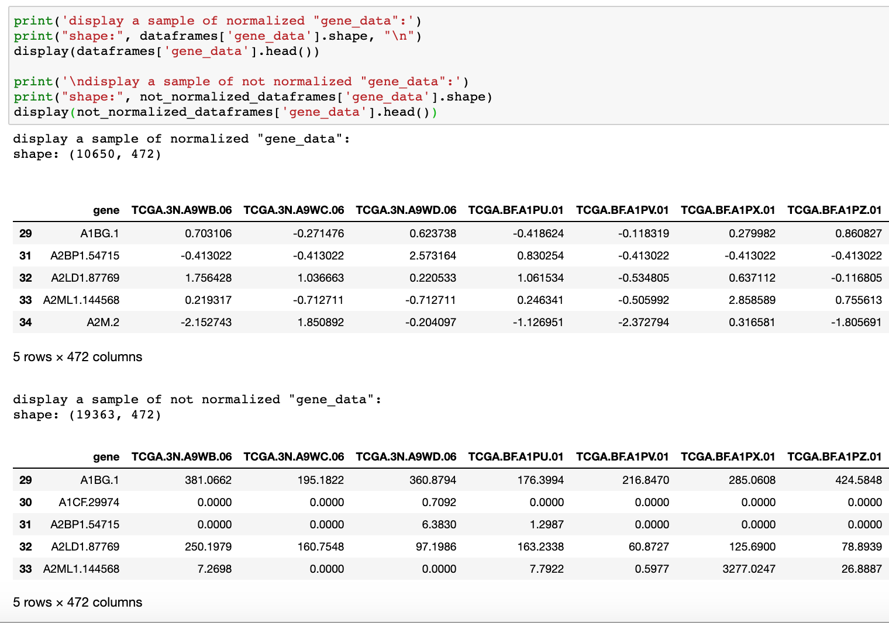

* **Micro RNA Data** (file titled “mirna”):

**Dataset Description:** The dataset includes mRNA as rows and samples of primary tumors (ending in ‘01’) and metastases (ending in ‘06’) as columns. The data values represent expression in the samples (with a minimum value of 0).

**Cleaning the Data:** Irrelevant sample columns were removed from the dataset (ending in ’07’, ‘11’).

**Data Shape:** The dataset includes 1046 mRNAs and 449 samples (97 primary samples and 352 metastases samples).

We converted this data into two datasets:

* + **dataframes[‘micro_rna_data’]:** a normalized dataset with 575 mRNAs and 449 samples created by:

1. performing log2(val + 1) to counts
2. removing features (mRNAs) with low variance (we chose to remove values with variance below the 45th percentile)
3. per mRNA value, subtracting the row mean (mRNA mean) and dividing by row std (mRNA std), resulting in a mean of 0 per row and std of 1.
   * **not_normalized_dataframes[‘micro_rna_data’]:** the original data (after cleaning) without normalization, containing 1046 rows (mRNA) and 449 samples.

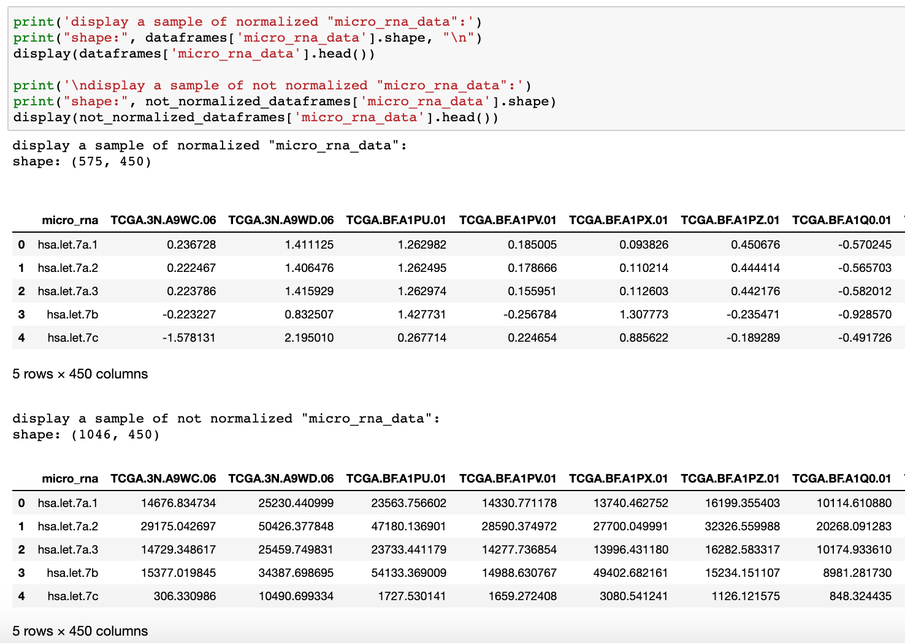

* **Survival Data** (file titled “survival”):  specifying whether the patient sampled died or not

**Dataset Description:** The dataset includes patients (samples) as rows and 3 columns: [‘PatientID’, ‘Survival’, ‘isDead’]. If the patient died, isDead is 1. Survival indicates the number of days until the patient either died or stopped being part of the study

**Data Shape:** The dataset includes 481 patients.

We converted this data into one dataset**: dataframes[‘survival_data’]**

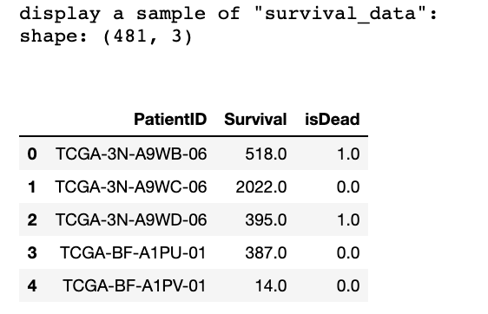

Downloaded clinical data for the same samples

* **Clinical data for melanoma patients** (“melanoma”):

**Dataset Description:**This dataset includes 479 rows, each row defines a sample (01 or 06). The columns (103) describes the clinical data itself, for example: location of the tumor in the patent body, types of treatment, age and a lot more. We used this data to divide the genes and micro RNA datasets according to the different organs in section 2.

**Issues Loading Data:** We encountered a problem in loading two rows, row 38 and 39 in the original dataframe. The problem is that they are series with 3 elements and contain 104 features instead of 102 like the other rows.

We attempted to load the data in three different ways:

* + - * + Using pandas (python) with various load versions, including converting the original file to different file types
        + Using RStudio (after consulting with Nimrod, we were told loading the data should automatically work, but it did not, and we actually tried to learn some R just for this!)
        + Examining the data in excel to manually figure out and resolve row issues

After multiple failures we decided to download the data without the two rows.

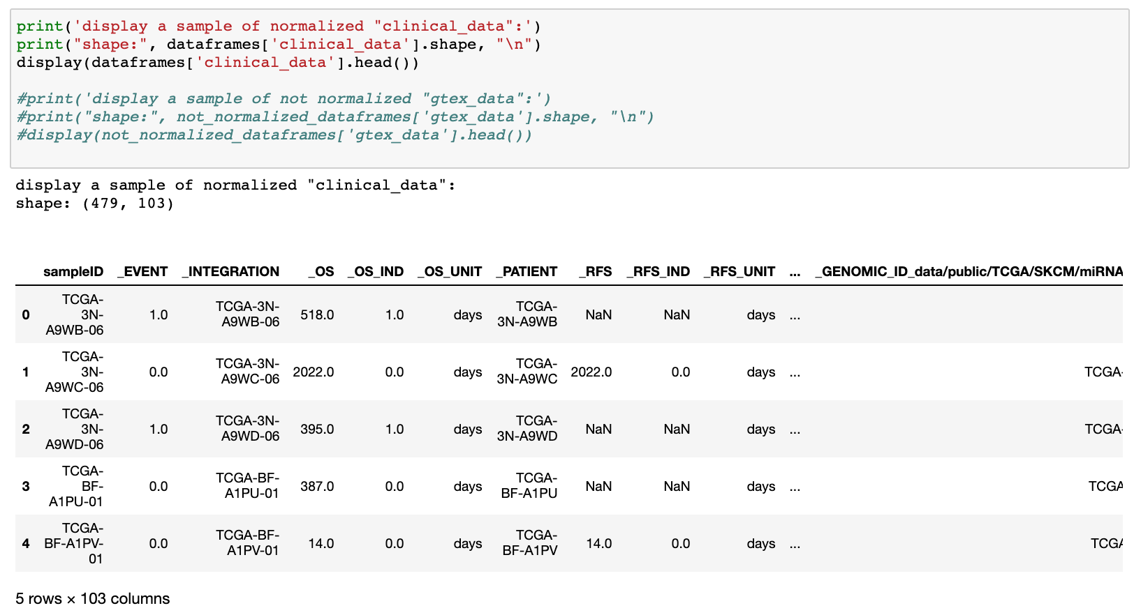

**2. GTEX Data** – Gene expression data for healthy skin samples, downloaded from a folder shared by Nimrod.

**Dataset Description:** The dataset includes genes as rows and samples healthy skin as columns. The data values originally represented some form of counts of gene expression in the samples, however these were calculated differently from counts used as gene expression for TCGA data. Gene names are formatted as ensemble_ids, and there is no exact 1:1 match between gene id from “exp” and ensemble_ids from gtex due to disagreements regarding what is considered a gene.

**Normalization:** we received the data already partially normalized:

* + - * + The mean per row (gene) was already set to zero, while the std was not set to 1
        + In order to complete the normalization process, we divided values in each cell by the relevant gene row std (and thus set the std to 1)

**Data Shape:** The dataset includes 16593 genes and 393 samples.

We converted this data into two datasets:

* + **dataframes[‘gtex_data’]:** this is a normalized version of the dataset, that is further-edited as a part of question 4 to include only ensemble_ids that we managed to match to genes found in TCGA gene expression data
  + **not_normalized_dataframes[‘gtex_data’]:** as mentioned, the data was received already partially normalized, so this dataset is also partially normalized

## Additional Datasets Used To Complete Project

* **Conversions:** This dataset was created in order to convert between ids used in gtex (ensemble_ids) and ids used in TCGA gene expression data (gene name/symbol. NCBI gene id). It was made by combining 34 files downloaded from <http://www.ensembl.org/biomart/martview/> (the process used for obtaining these files is described in Data Analysis Description: Section 4).

We converted this data into one independent dataset: **‘conversions’**

* **Immune Genes:** This dataset lists genes that are related to the immune system, downloaded from <https://www.immport.org/shared/> based on a description in <https://www.innatedb.com/redirect.do?go=resourcesGeneLists>. This dataset was used in Section 7.

We converted this data into one dataset: **dataframes[‘immune_genes’]**

# Main Methods Used

## 

## Hierarchical Clustering

### **What is clustering?**

Clustering is a technique to group similar data points in a way that places more similar points in the same group. A cluster is a group of similar points. In the following project we will use the Hierarchical Clustering method. There are 2 types of hierarchical clustering, agglomerative and divisive.

* agglomerative: data points are clustered using a bottom-up approach starting with individual data points
* divisive: data points are clustered using top-down approach

In this project, we will use the agglomerative technique. The clustering works as follows:

1. Each data point will be considered a separate cluster (we will have k clusters for k data points)
2. The two closest data points will be joined, creating k-1 clusters
3. Keep iteratively joining the two closest clusters until we get one cluster

The clustering results can be visualized using a dendrogram.

### **Hierarchical Clustering Methods:**

we will describe 3 methods, that according to our research are the most commonly used methods in studies, though more methods exist:

1. complete/max/farthest neighbor: the distance between two clusters is defined as the longest distance between two points in each cluster.
2. average: the distance between two clusters is defined as the average distance between each point in one cluster to every point in the other cluster.
3. ward/minimal increase of sum-of-squares: uses ward's method: similar to average, but using the sum of the square of the distances. Proximity between two clusters is the magnitude by which the summed square in their joint cluster will be greater than the combined summed square in these two clusters.

### **How can we select a method to use?**

- One possibility is to use the to calculate the cophenet, because the correlation between the distance matrix and the cophenetic distance can help suggest clustering method to choose. We want to select the method where the correlation between the original distances and the cophenetic distances is high.

### **Which packages will we use for the analysis?**

- we used scipy for selecting a clustering method, performing hierarchical clustering and displaying a dendrogram

## PCA

### **What is PCA?**

* Principal Component Analysis (PCA) is a statistical procedure used to convert a set of observations with multiple dimensions (features, variables) that might be correlated into a group of linearly uncorrelated variables (principal components) using orthogonal transformation.
* The variables are transformed into a new set of variables, known as principal components (PCs) that ar orthogonal and ordered in a way where the variation present in the PCs decrease as we move from the 1st PC to the last one
* PCA is an unsupervised method and it’s difficult to interpret the features used to create the main resulting PCs as they are some complex mixture of the original features.

Without getting into math, PCA works as follows:

1. Normalize the data
2. Calculate a matrix that summarizes how our variables are related (the covariance matrix)
3. Break the matrix down into separate components of direction and magnitude
4. Transform the original data to align with the important directions we found

### **How can we select the number of principal components to use in our calculation?**

* When we graph, we can use only 2 PCs for a 2D graph and 3 PCs for a 3D graph
* However, we need to select a relevant number of components to be used in our calculation
* Various methods exist to select, we will plot the cumulative explained variance per component and select a number of components before where the graph slope becomes relatively steady

### **Which packages will we use for the analysis?**

* we used sklearn for performing PCA

## Differential Expression Analysis

### **What is Differential Expression Analysis?**

* Differential gene expression analysis is a group of statistical tests used to determine if per gene there is a significant variation across a set of tested conditions.
* These tests can be used to compare between expression in two groups of samples, for example: a comparison between expression in primary (01) samples vs metastases samples (06) or a comparison between healthy skin samples (gtex) vs tumor samples (tcga gene expression)
* We will use differential expression analysis for analyzing gene expression and micro RNA expression, in questions 2 - 7

We selected to use 2 different methods for DE Analysis:

* Welch's t-tests: a two-sample location test which is used to test the hypothesis that two populations have equal means.
* Rank Sum tests: a test based on ranking observations of the combined samples so that each observation gets a rank (1 for the smallest, 2 for then next, and so on), and the rank-sum test statistic is the sum of the ranks for observations from one of the sample types.

### **How do we define a highly-expressed/slightly-expressed gene?**

* To determine if a gene has been significantly expressed, we will use genes/miRNAs where:
  + P-value: is less than 0.01 (this was an arbitrary selection because we got a lot of results for 0.05)
  + log2FoldChange: we read that fold-change of +/- 2 is often used as the threshold for defining significant differential expression, therefore we will use a minimum of log fold-change +2 to define highly-expressed genes and a maximum of -2 to define slightly expressed genes. However, we will select actual values to use by examining an MA-Plot and seeing outlying values graphically. (specifically, we noticed that with our data, the limits of -7.5/+7.5 were actually better in many cases)
* When we say a gene/miRNA is highly/slightly expressed, we mean that we got it as a result from t-test, rank sum tests, or both. After we perform each test, we combine the results in order to get a more robust result.

### **Which packages will we use for the analysis?**

* differential expression analysis using diffxpy (installation instructions: https://github.com/theislab/diffxpy/blob/master/docs/installation.rst)

### **Graph description:**

1. MA graph - this plot is a 2D plot that shows the log2-fold change vs mean expression.
2. Volcano graph - is a 2D scatter plot shaped like a volcano . It is used to show statistically significant gene expression changes from two different conditions. It displays log fold change vs p-value. For each section we will display our t-test volcano plot and our rank-sum test volcano plot.
3. Log10 p-value for t-test (x) vs log10 p-value for rank-sum test (y)

# Data Analysis Description

## Section 1:

Question

If we look at gene expression data of primary tumors and metastases together, is there a clear distinction between them? Does such a distinction exist for micro RNA?

### Analysis Description

**General Description**: In order to find a distinction between primary tumors and metastases, we will attempt to cluster our data by sample to create clusters of primary samples ('01') and clusters of metastases samples ('06'), using hierarchical clustering. We will then perform PCA and graph the results of clustering on the main PCs, so that we can visually compare plots of actual primary/metastases samples to plots as a result of cluestering. If we find similar results, we will have found a clear distinction between primary and metastases samples. This process will be performed once for gene expression data and once for micro RNA data.

The following process was be performed once with normalized gene expression data and once with normalized miRNA expression data:

* A method for hierarchical clustering was selected by comparing the cophenet of 3 possible methods: 'ward', 'complete', 'average'
* Clustering was performed by sample (01, 06 samples) using 2 separate methods
* Results of clustering were displayed using a dendrogram (a useful tool to display biological clustering)
* Results of clustering were analyzed as follows:
  + Clustering results were examined for k # of clusters = [2, 4, 10, 15, 25, / 35, 45] (additionals for miRNA)
  + Per k, each cluster was examined:
    - We checked if the cluster has resulted in a higher percent of actual 01 samples / actual 06 samples
    - Based on the analysis, we defined each cluster as 'primary', 'metastases' or 'unknown'
* We selected one of the clustering methods for a specific k for further analysis
  + for gene expression: k = 25, method = 'complete'
  + for miRNA: k = 45, method = 'ward'
* We displayed the data matrix graphically as a scatter plot in 2D (this shouldn't make much sense because data is multi-dimensional, but gives a good understanding of data point types and the quality of clustering)

1. one graph is displayed by actual 01/06 sample
2. one graph is displayed by cluster
3. one graph is displayed by 01/06 sample **based on clustering results**

* We performed PCA to find new axis (PC1, PC2, PC3) to display our data on
  + we normalized the data so that all data points are between 0 and 1
  + we performed analysis of a how many components to use for the PCA
  + we performed PCA for number of components selected
    - for gene expression: n_components = 300
    - for miRNA: n_components = 250
  + we calculated the explained variance % per PC and specifically examined the % for PCs 1, 2 and 3
  + we graphed the data in 2D (PC1 as x, PC2 as y) and in 3D (PC1 as x, PC2 as y, PC3 as z)

1. one graph section displayed the data points colored by actual sample type (primary, metastases) based on sample name
2. one graph section displayed the data points colored by cluster
3. one graph section displayed the data points colored by cluster sample type (primary, metastases, unknown) **based on clustering results**

Main Visualizations (more exist in the jupyter notebook!)

1. **gene data:**
   1. dendrogram resulting from hierarchical clustering with 'complete' method

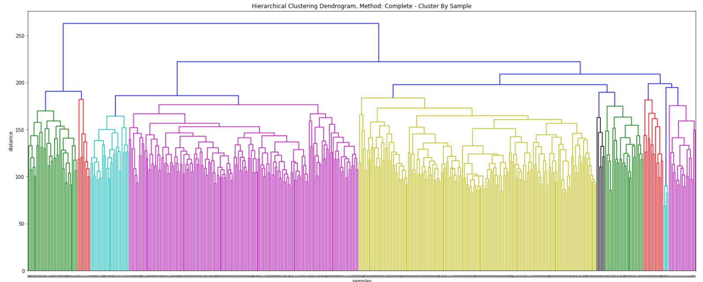

* 1. accuracy calculated for resulting clusters for k clusters where k=15, k=25. For the rest of this analysis we will select to use k=25

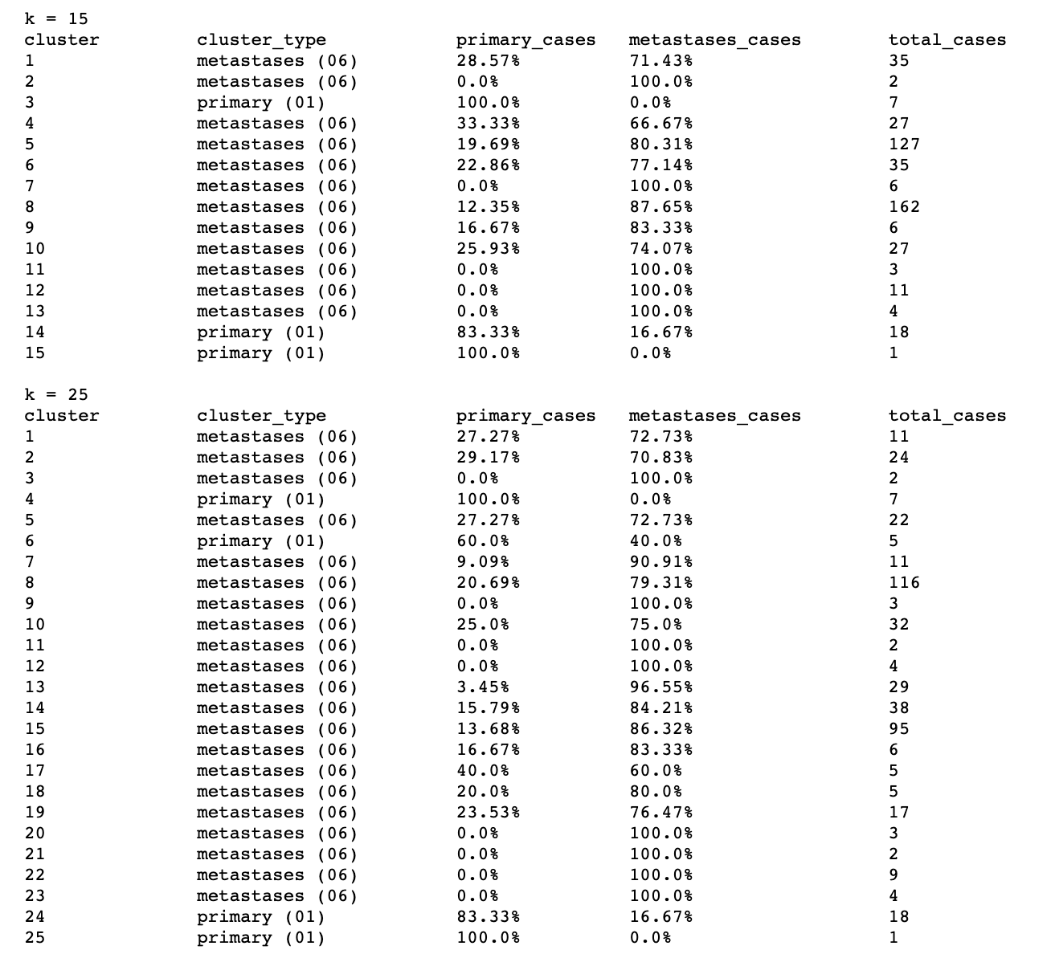

* 1. Graph used to select the number of components to use for PCA calculation

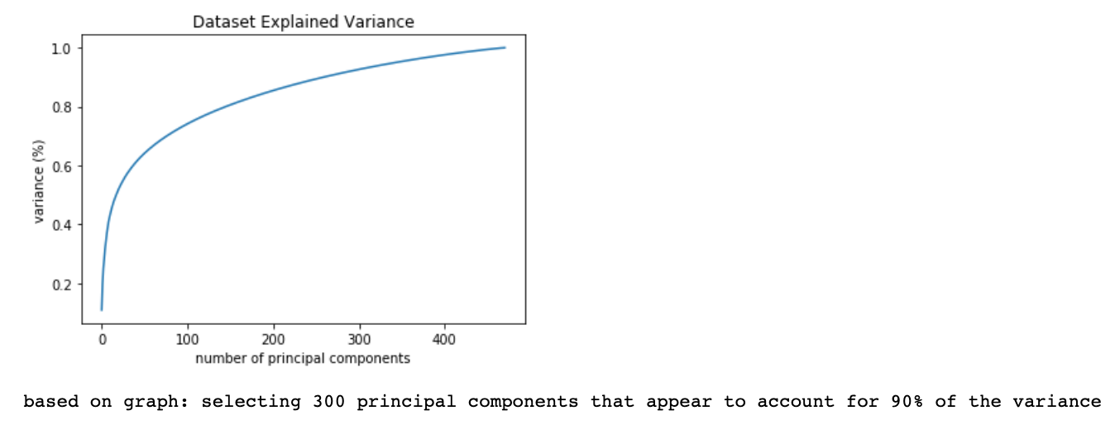

* 1. Plotting the explained variance per principal component and calculating the cummulative explained variance for the first 3 components

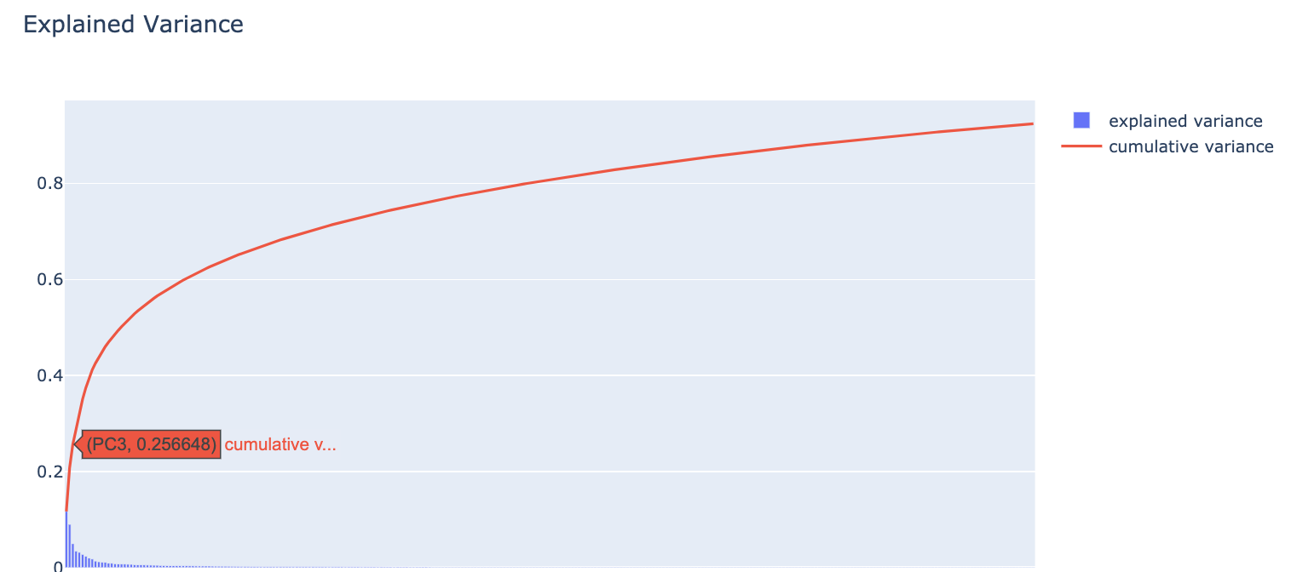

* 1. Plotting data on PCs (2D). We will use PC1 as x, PC2 as y and create 3 graphs:
     1. graph 1: data points colored by actual sample type (primary, metastases)

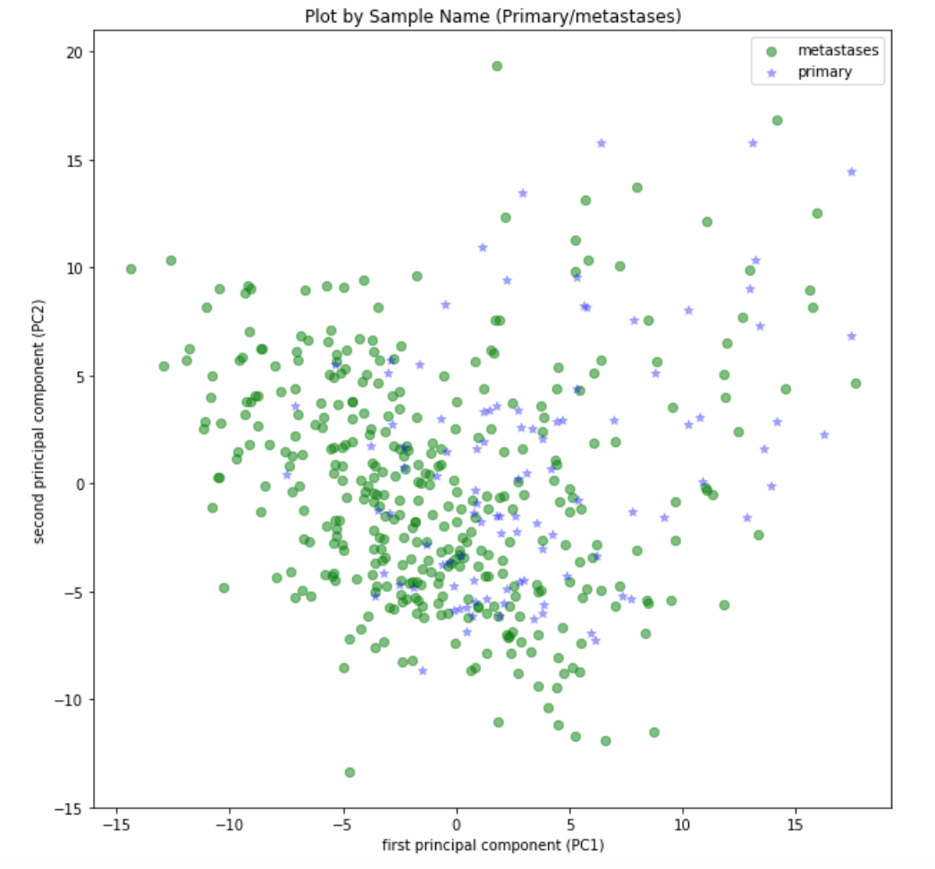

* + 1. graph 2: data points colored by cluster

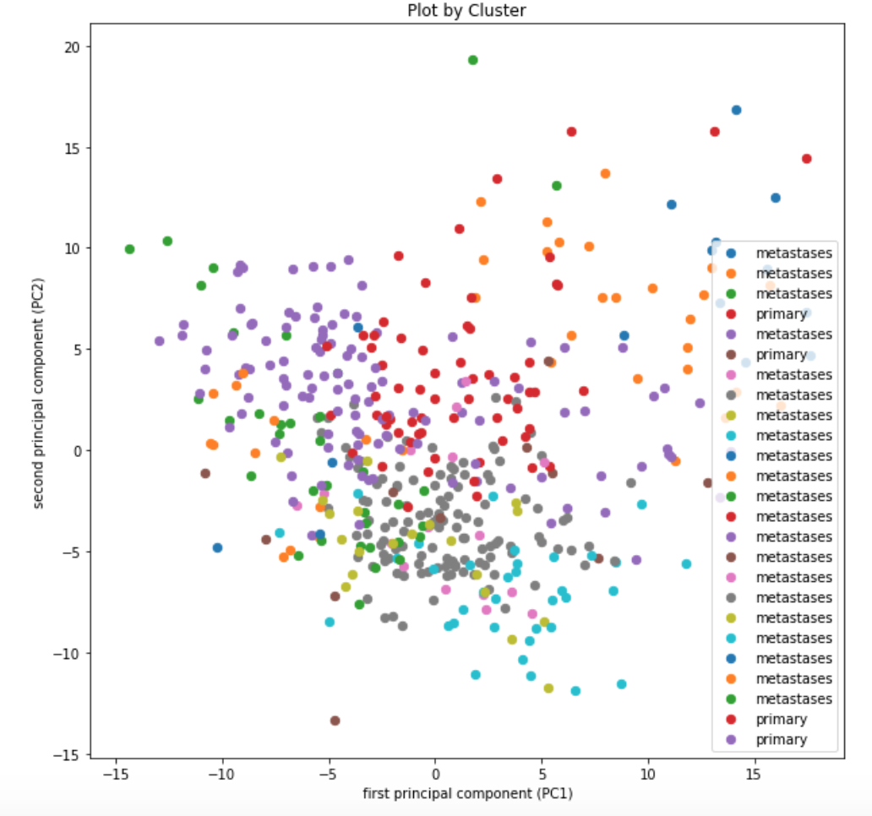

* + 1. graph 3: data points colored by cluster sample type (primary, metastases, unknown) based on clustering results

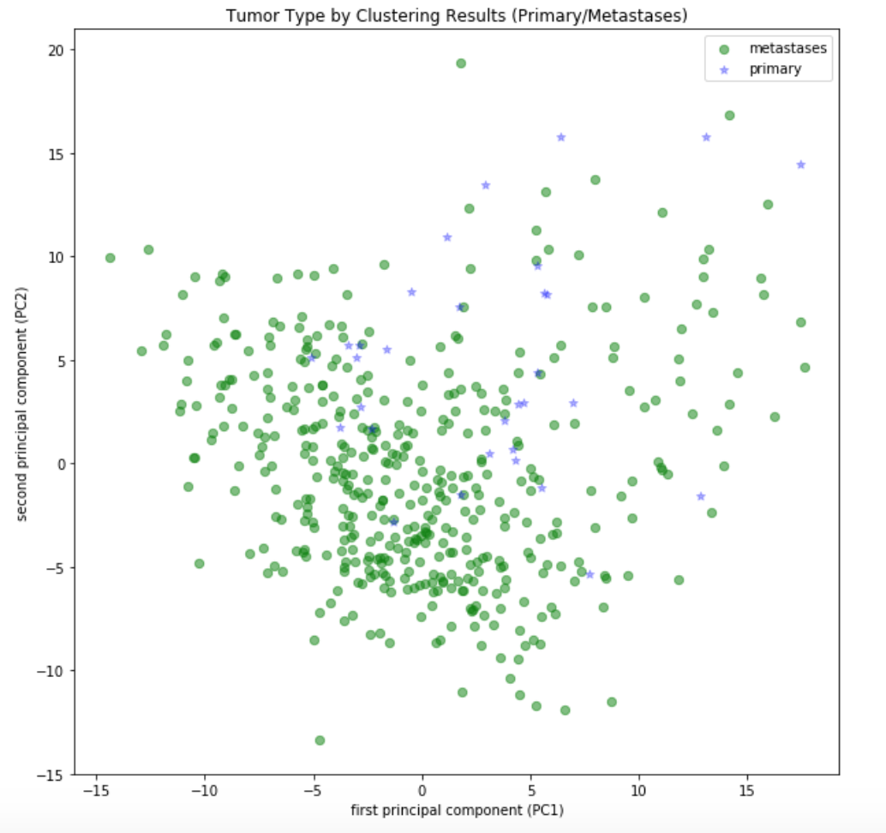

* 1. Plotting data on PCs (3D). We will use PC1 as x, PC2 as y, PC3 as z and create 3 graphs:
     1. graph 1: data points colored by actual sample type (primary, metastases)

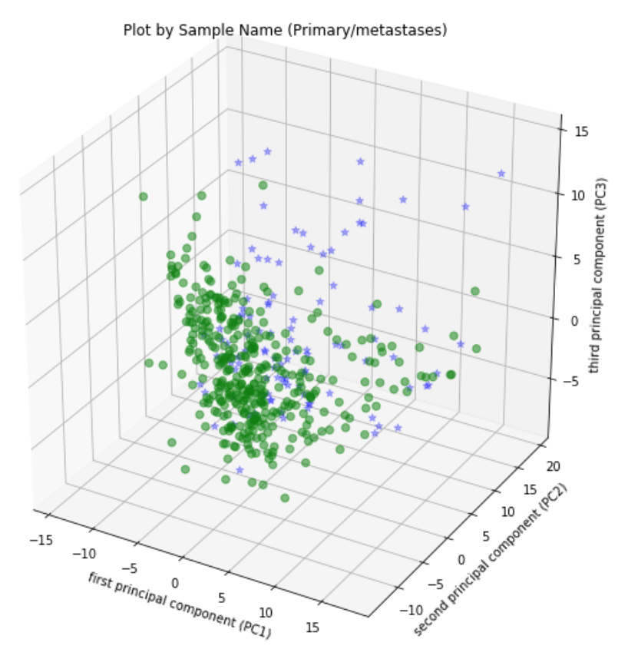

* + 1. graph 2: data points colored by cluster

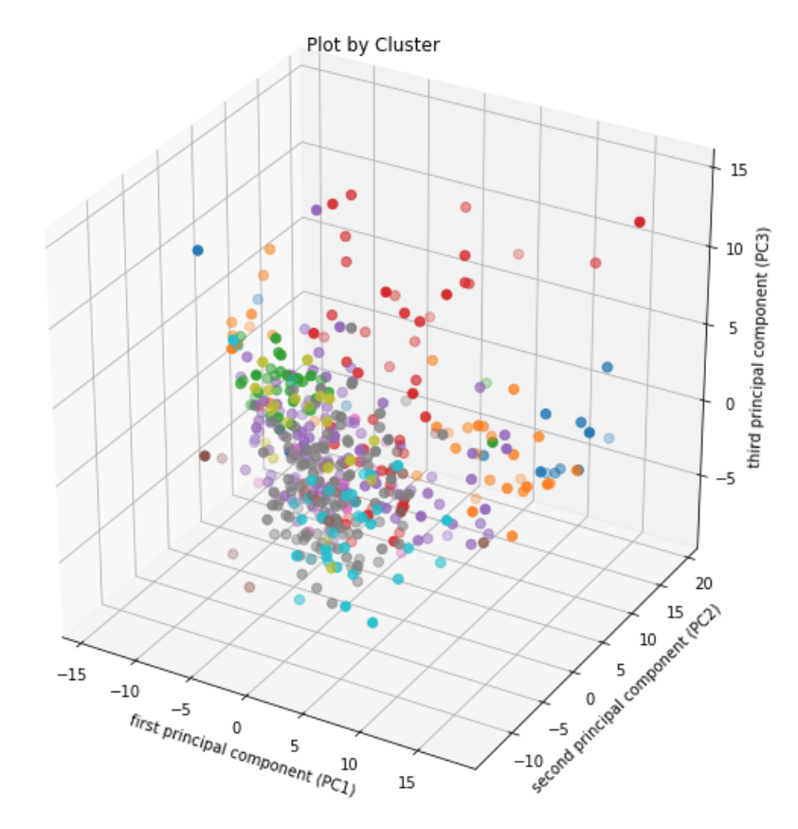

* + 1. graph 3: data points colored by cluster sample type (primary, metastases, unknown) based on clustering results

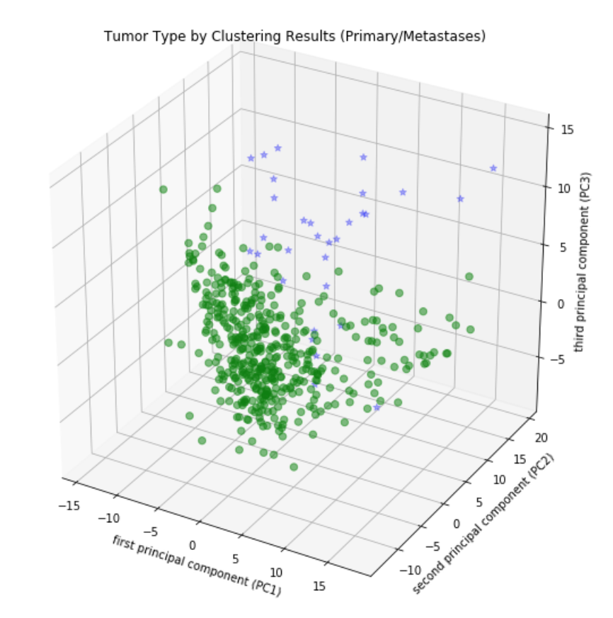

1. **micro rna data:**
   1. dendrogram resulting from hierarchical clustering with 'ward' method

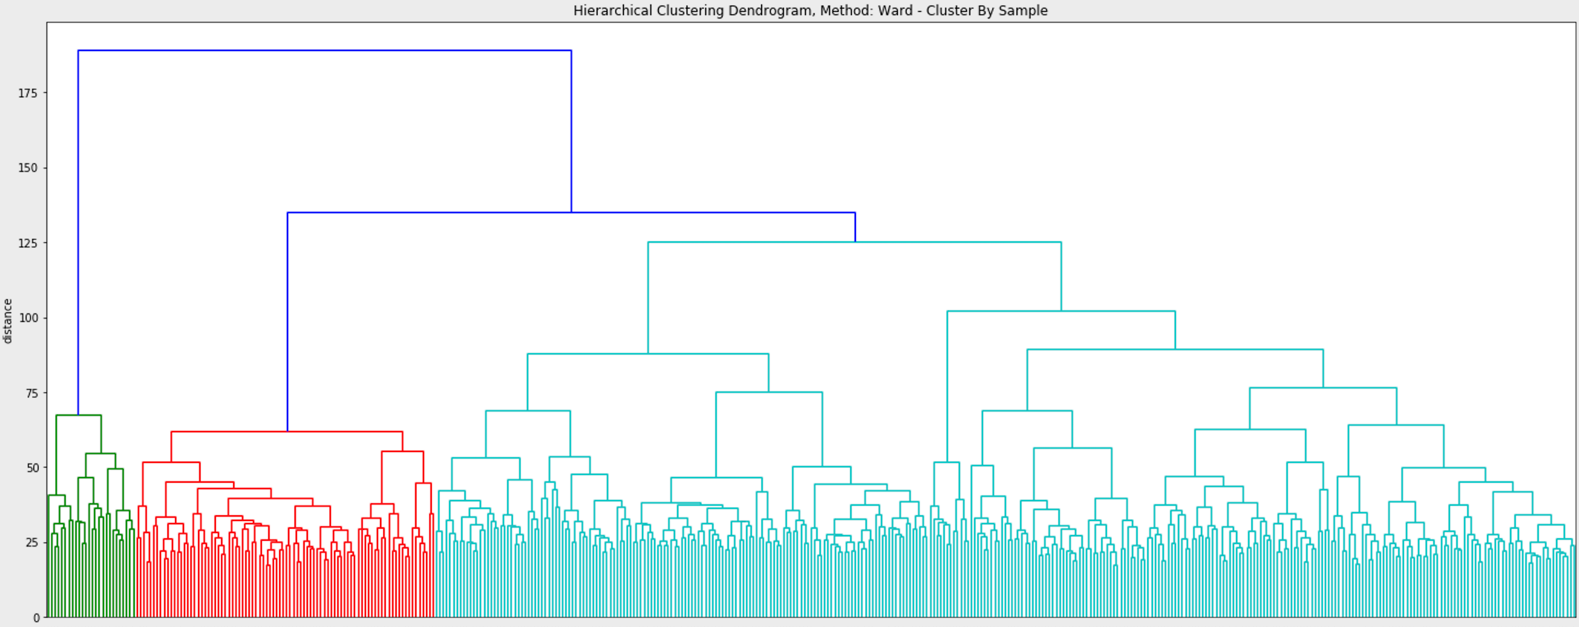

* 1. accuracy calculated for resulting clusters for k clusters where k=45.

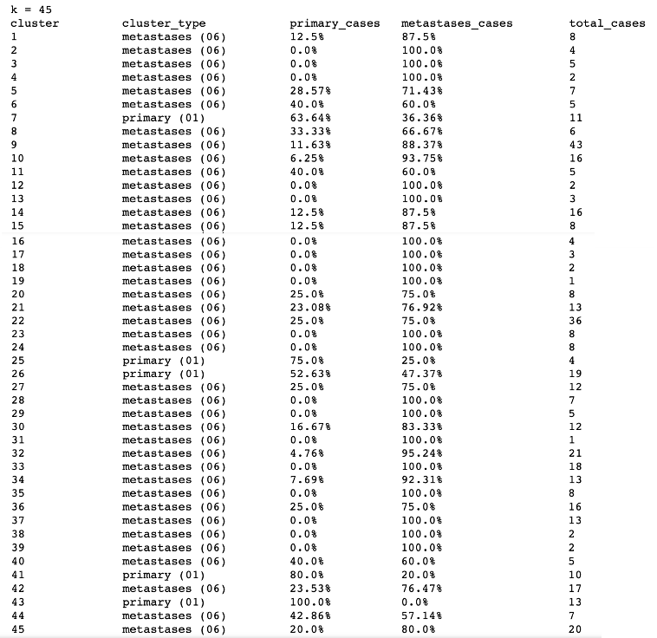

* 1. Graph used to select the number of components to use for PCA calculation

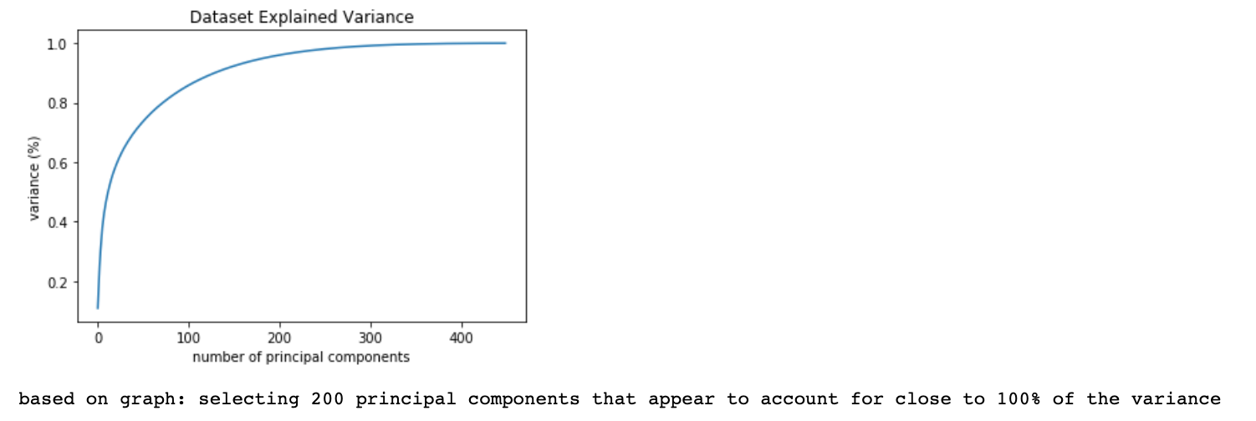

* 1. Plotting the explained variance per principal component and calculating the cummulative explained variance for the first 3 components

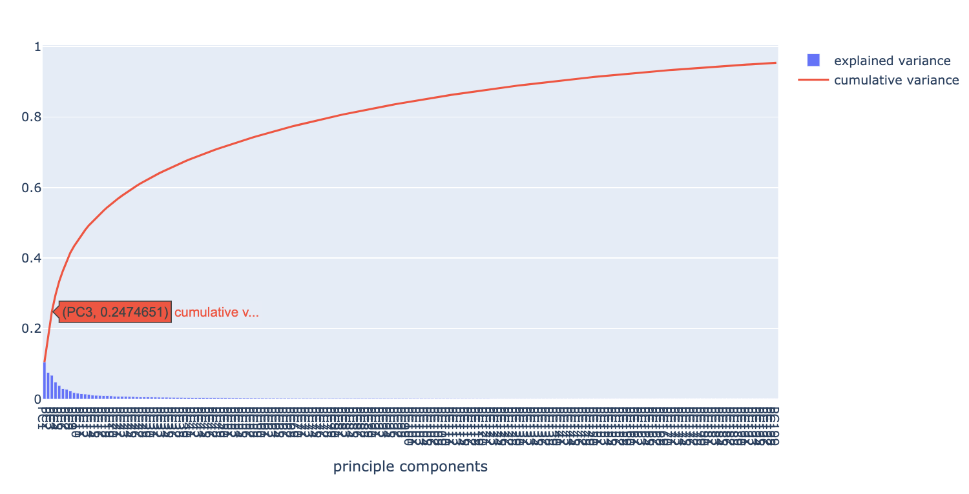

* 1. Plotting data on PCs (2D). We will use PC1 as x, PC2 as y and create 3 graphs:
     1. graph 1: data points colored by actual sample type (primary, metastases)

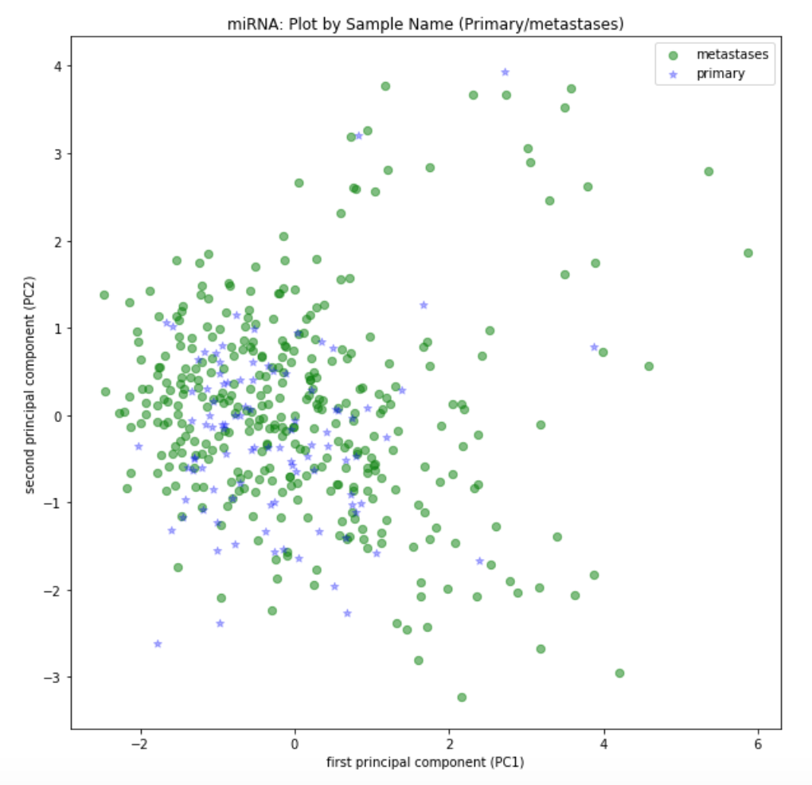

* + 1. graph 2: data points colored by cluster

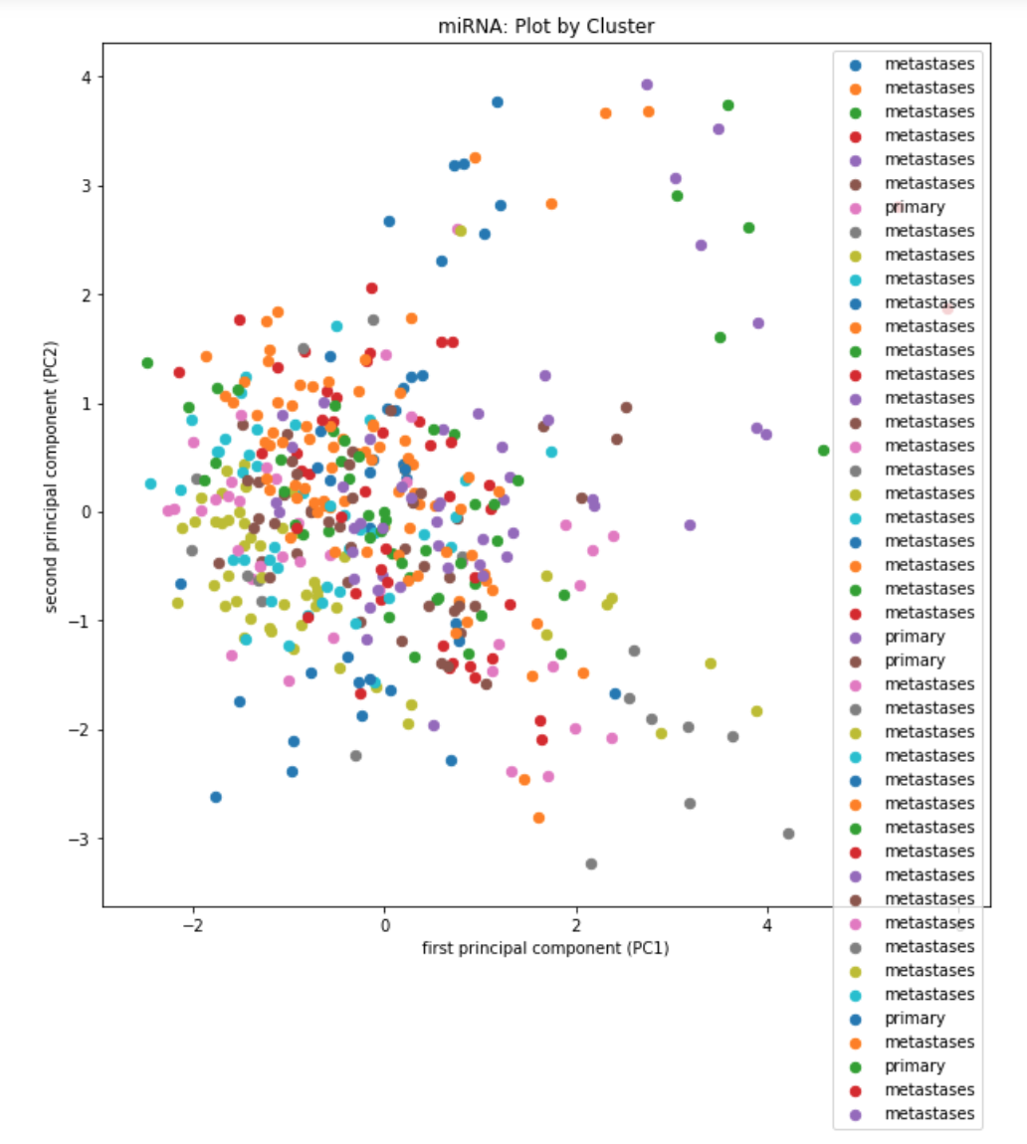

* + 1. graph 3: data points colored by cluster sample type (primary, metastases, unknown) based on clustering results

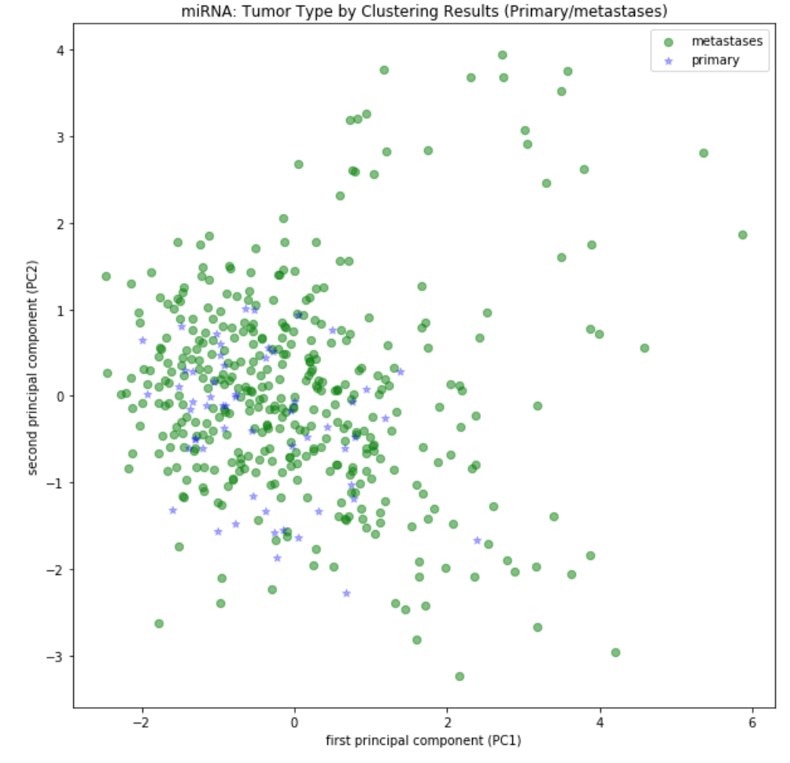

* 1. Plotting data on PCs (3D). We will use PC1 as x, PC2 as y, PC3 as z and create 3 graphs:
     1. graph 1: data points colored by actual sample type (primary, metastases)

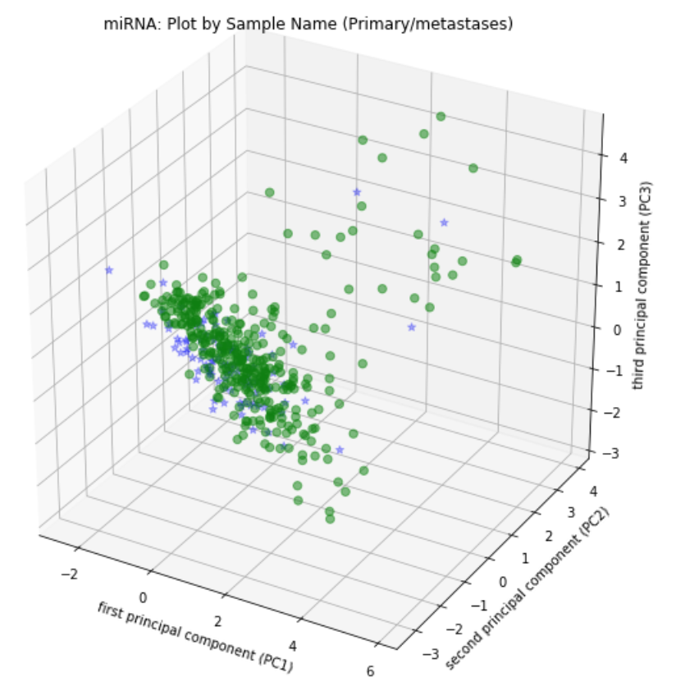

* + 1. graph 2: data points colored by cluster

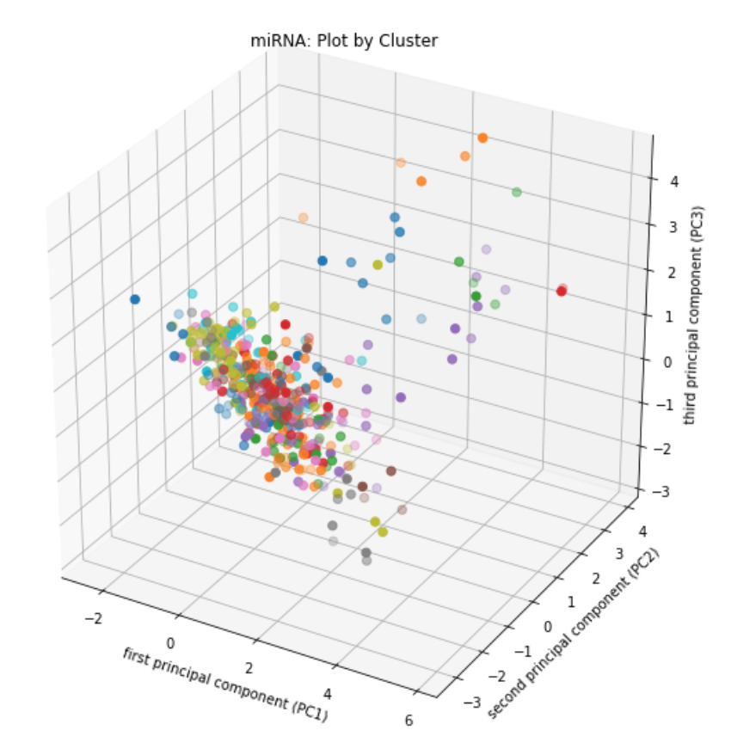

* + 1. graph 3: data points colored by cluster sample type (primary, metastases, unknown) based on clustering results

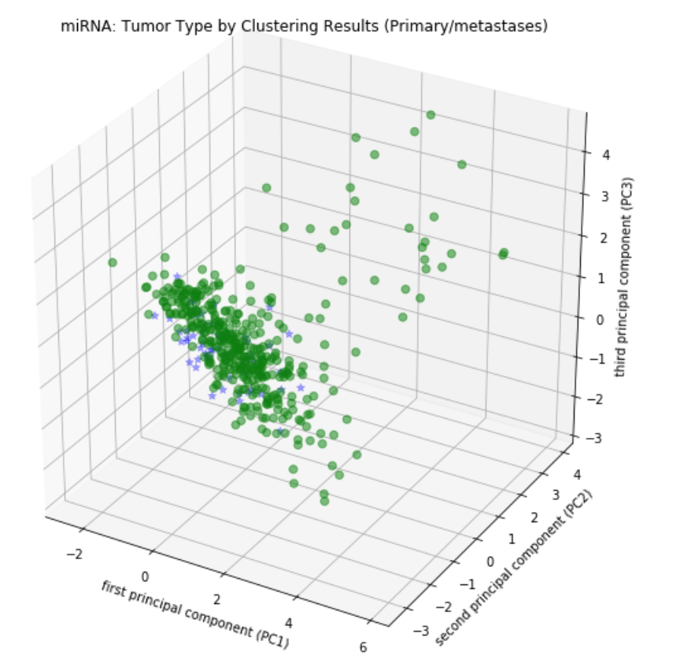

### Conclusion

The clustering process proved difficult as there were few primary samples compared to metastases samples. However,

* For gene expression data, our clustering into k=15 clusters gave relatively good results, and clustering into k=25 clusters gave even better results. Graphing on main PCs shows us that some areas of actual 01 samples are well recognized by our clustering, specifically the top right area of the 3D PCA graph. In our opinion, the distinction between primary and metastases samples was pretty good considering the small number of 01 samples.
* For micro RNA expression data, our clustering into small ks resulted in very few distinctly primary clusters. In order to create relatively good graphical results, we had to use large ks, such as k=45. While the results for this k looked better, there is a high risk of overfitting in this case, so in our opinion the distinction between primary and metastases samples was not very good.

## Section 2:

### Question

a) Which genes and miRNA have a higher expression in local skin metastases vs primary tumor?

b) Which genes and miRNA have a higher expression in distant metastases?

c) Which genes and miRNA have a higher expression in lymph nodes?

d) Are the genes in the various organs similar?

**Defining highly-expressed genes**

Differential Gene Expression (DGE) Analysis: (see description in "Methods" section)

* To determine if a gene has been significantly expressed, we will use in this section:
  + P-value < 0.01
  + log2FoldChange: see values in the code (the usual boundary is +/-2)

### Analysis Description

**Perform Differential Gene Expression (DGE) Analysis**

Prep data for determining highly and slightly expressed genes/miRNA in a given non-normalized dataframe. As part of this process:

1. Divide dataframe into to 4 mini dataframes: primary tumor, local skin metastasis, distant metastasis, lymph nodes
2. Plot the relationship between mean and std for each mini dataframe.
3. Transpose full dataframe to get a matrix where samples are rows, dimensions (genes/miRNA) for columns
4. Create a sample types dataset, where the condition is defined as: if type one: 1, otherwise 0 (type one is each one of the mini dataframes every time).
5. Create an AnnData object that will hold our data matrix (X), sample descriptions, and and labels - and return it

Perform differential expression analysis

1. Run 2 types of tests on the data: Welch's t-test and rank sum test
2. Display an MA plot (this should be used to help define limits used to limit log2foldchange for high, low expression)
3. Graph volcano plots based on both tests to help differentiate significant values
4. Plot a comparison of both tests
5. Create a dataset of highly expressed genes/miRNAs and slightly expressed genes/miRNAs using p-value=0.01, log2foldchange: see values in the code for slightly expressed and highly expressed.
6. merge all highly expressed genes into one dataframe, slightly expressed genes into one dataframe
7. return highly expressed and slightly expressed dataframes for those groups:

* Distant metastasis
* Lymph
* Local skin metastasis
* Primary tumor

1. Finding common highly and slightly genes and miRNAs in those groups:

- Local skin metastases and primary tumor

- Local skin metastases, distant metastasis and lymph nodes

- Primary tumor, local skin metastases, distant metastases and lymph node

We find the common genes and in some groups we draw it in a graph (only if there are common genes).

### Relevant Visualizations - Genes

#### distant metastasis:

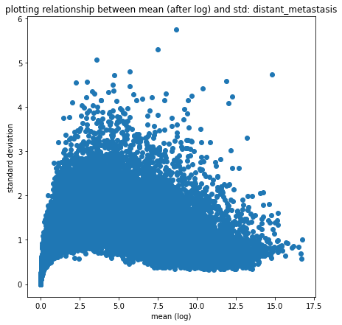

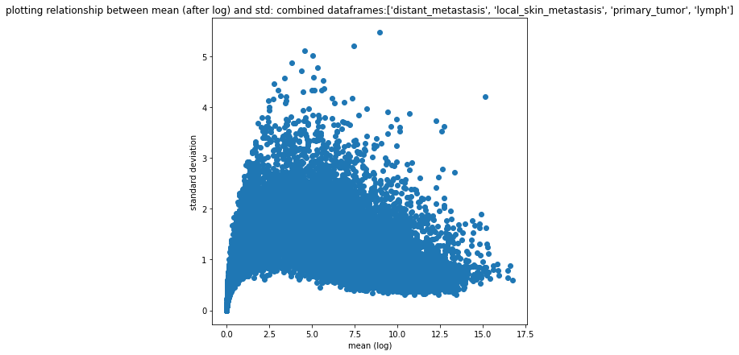

MA plot:

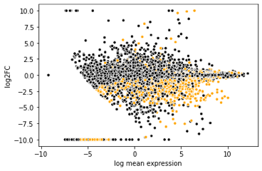

volcano plot:

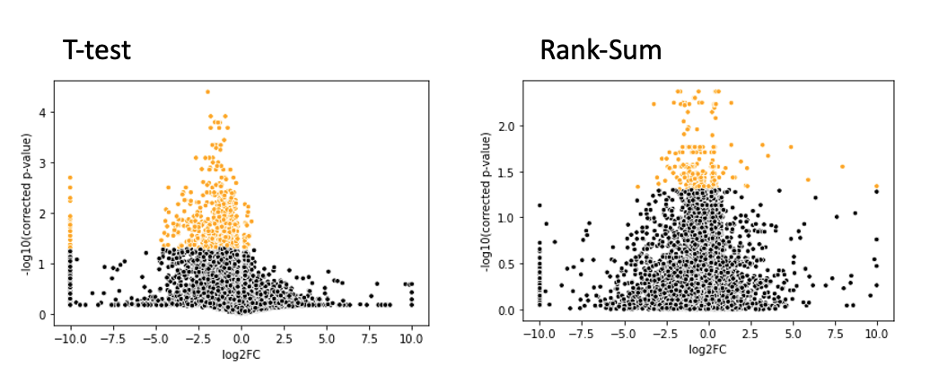

Log10_pval for t-test (x axis) vs log10_pval for rank sum test (y axis)

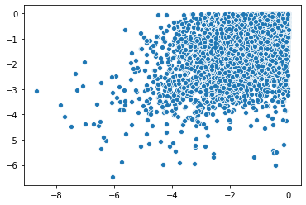

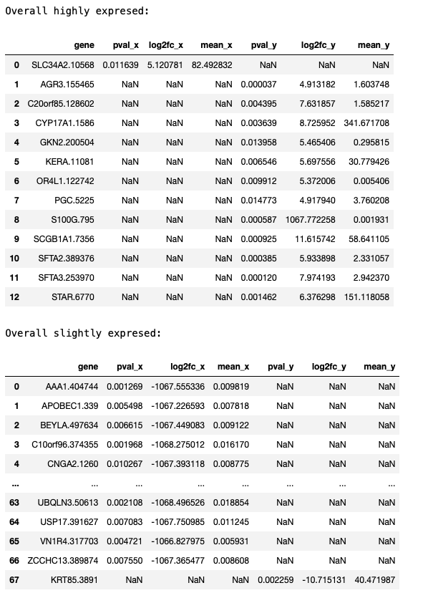

#### Lymph:

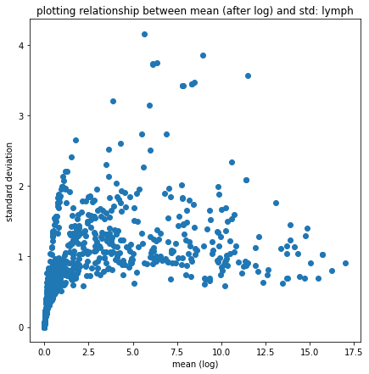

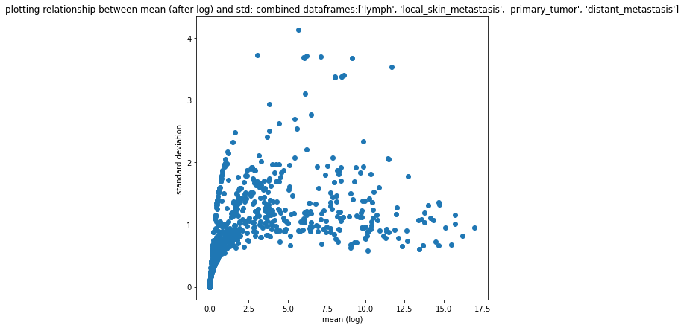

MA plot:

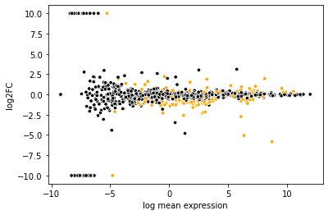

Volcano plot:

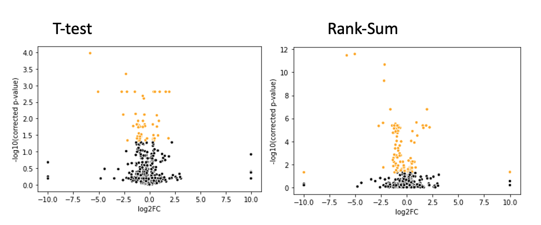

Log10_pval for t-test (x axis) vs log10_pval for rank sum test (y axis)

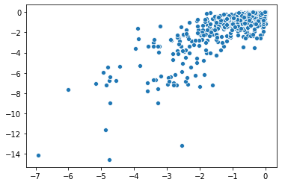

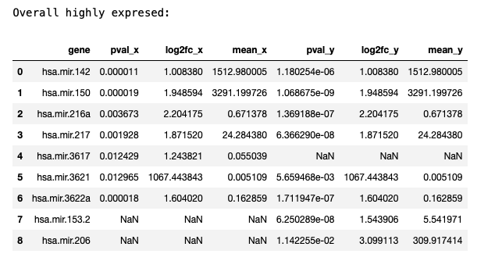

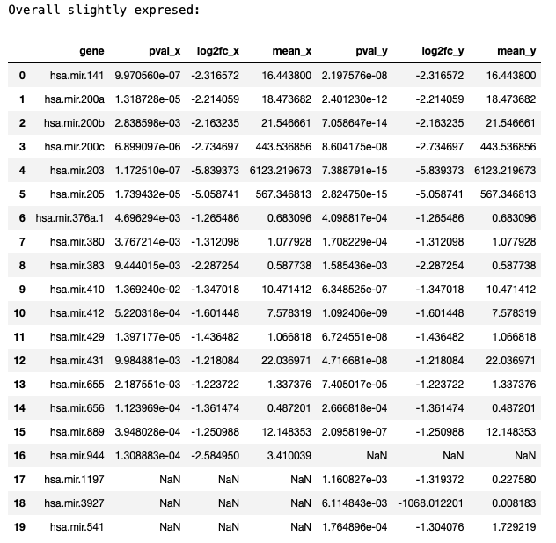

#### local skin metastasis

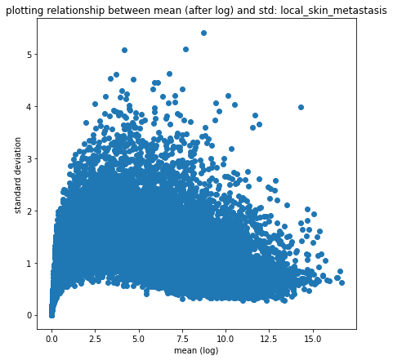

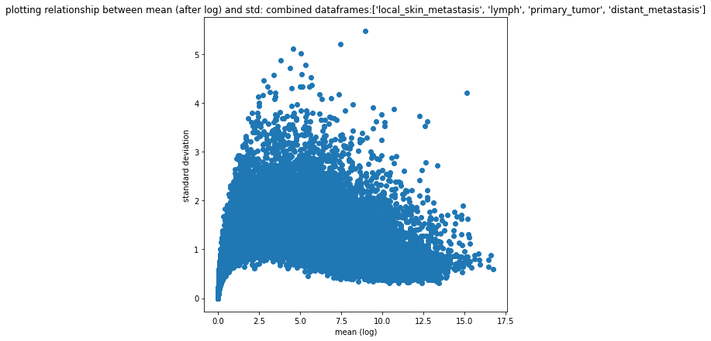

MA plot:

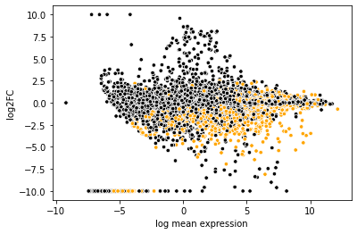

T-Test volcano plot:

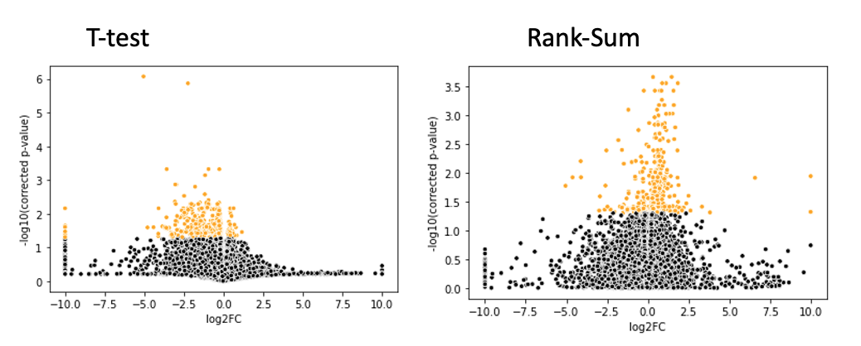

log10_pval for t-test (x axis) vs log10_pval for rank sum test (y axis)

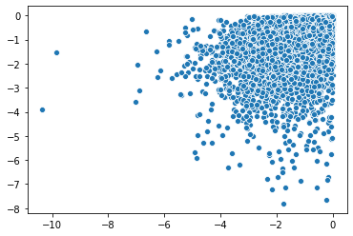

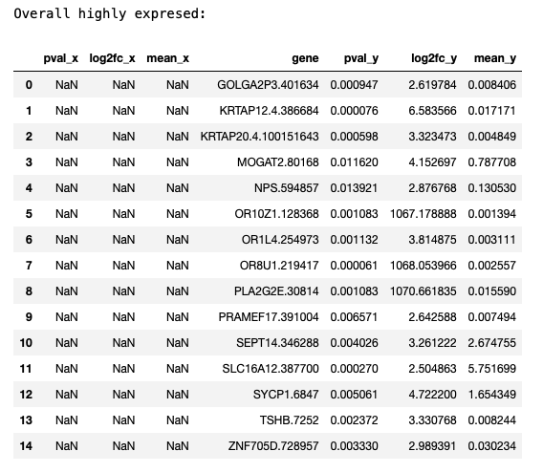

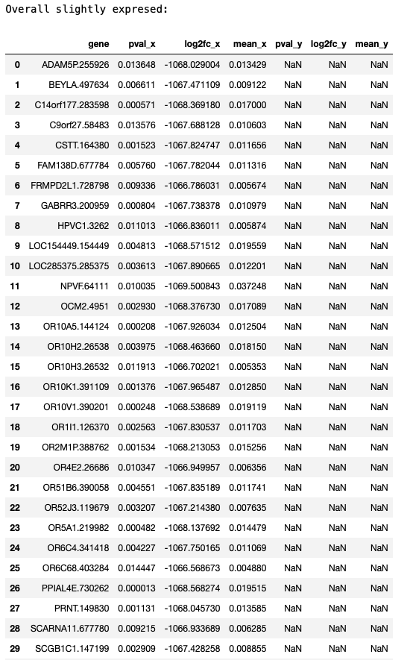

#### primary tumor

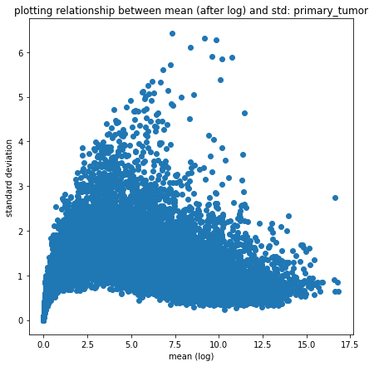

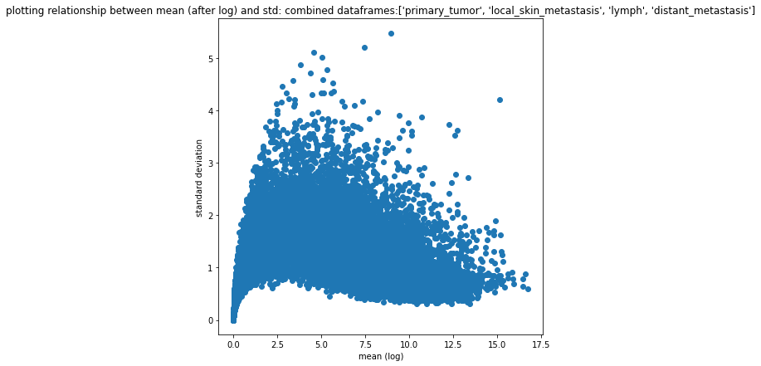

MA plot:

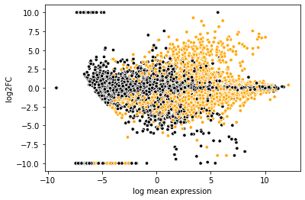

Volcano plot:

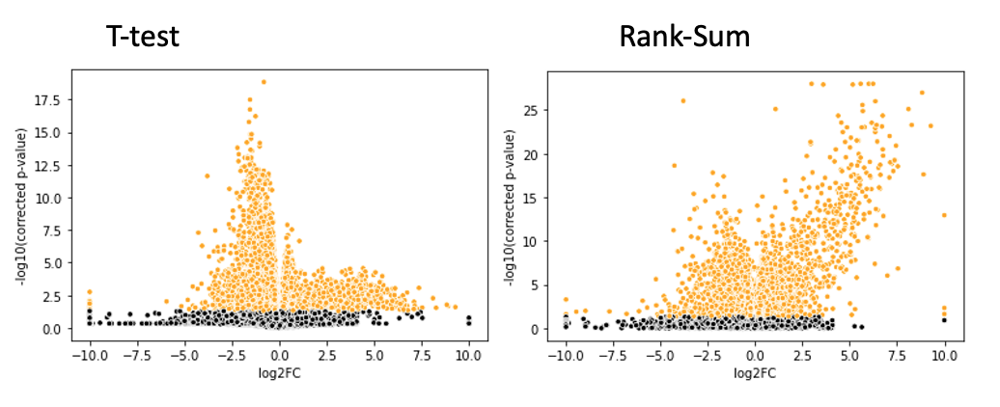

Log10_pval for t-test (x axis) vs log10_pval for rank sum test (y axis)

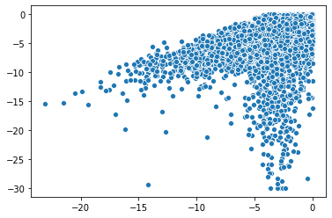

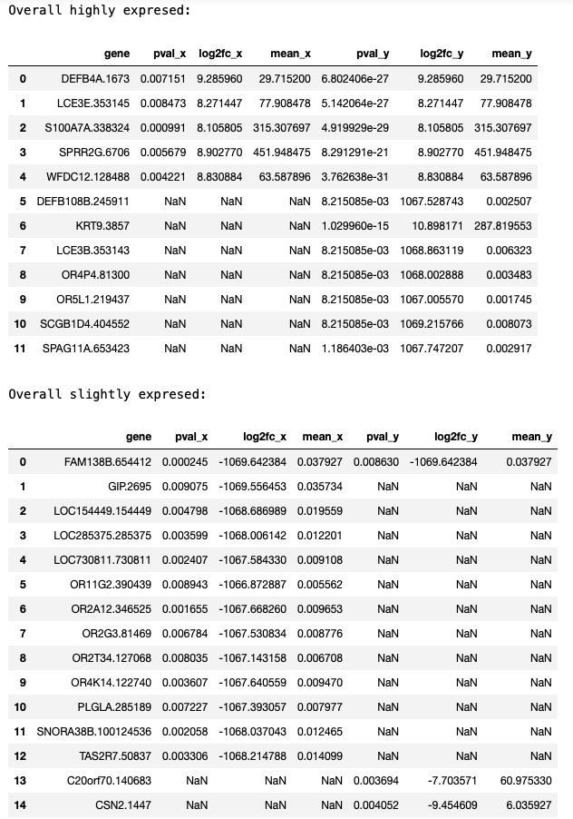

**Finding common slightly expressed genes in primary tumor, local skin metastases, distant metastases, lymph nodes**

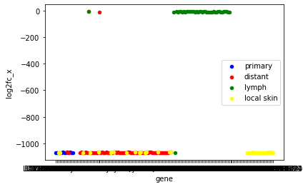

### Relevant Visualizations – Micro RNA

#### primary tumor

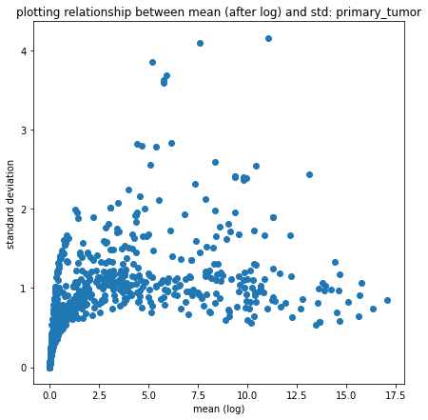

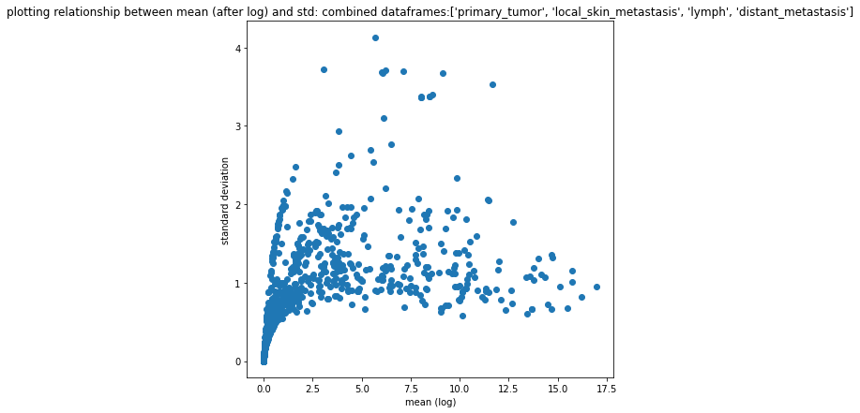

MA plot:

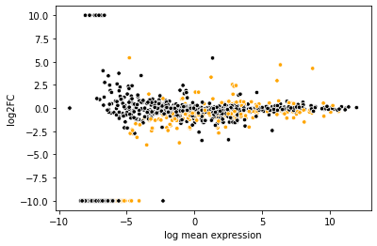

Volcano plot:

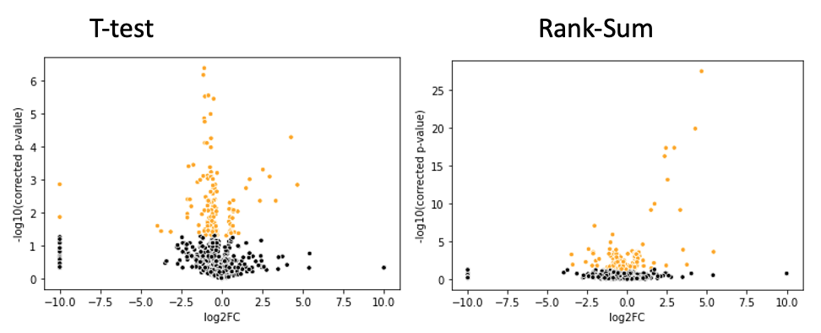

Log10_pval for t-test (x axis) vs log10_pval for rank sum test (y axis)

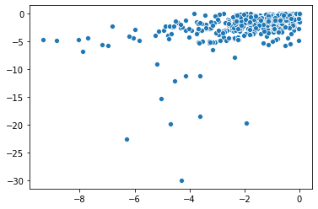

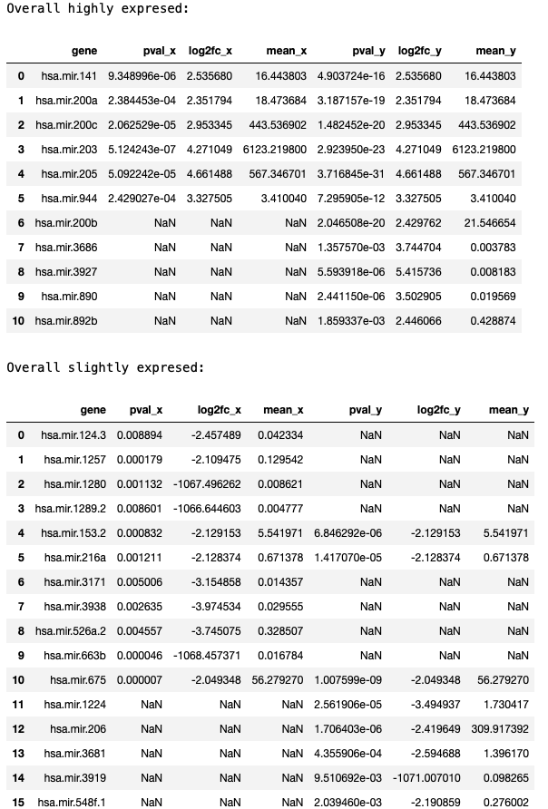

#### Lymph:





MA plot:



Volcano plot:

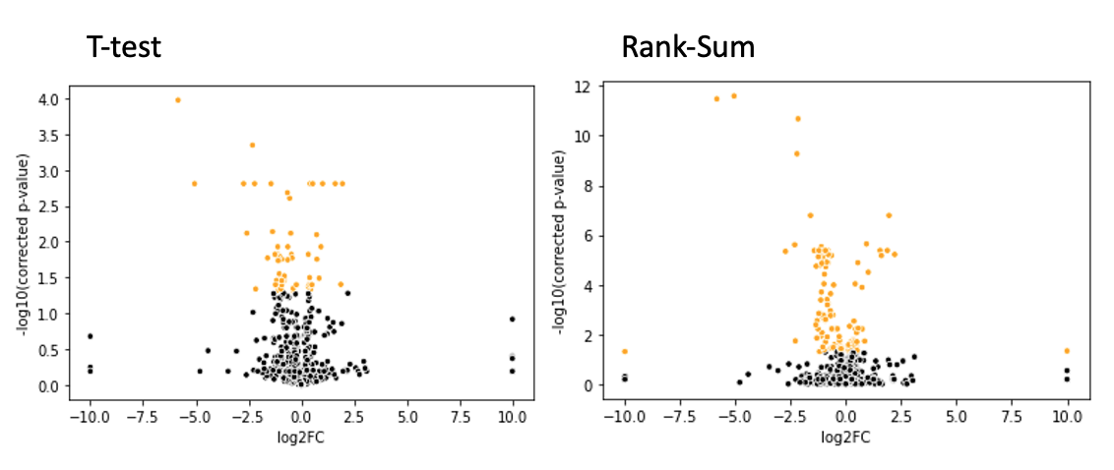

Log10_pval for t-test (x axis) vs log10_pval for rank sum test (y axis)



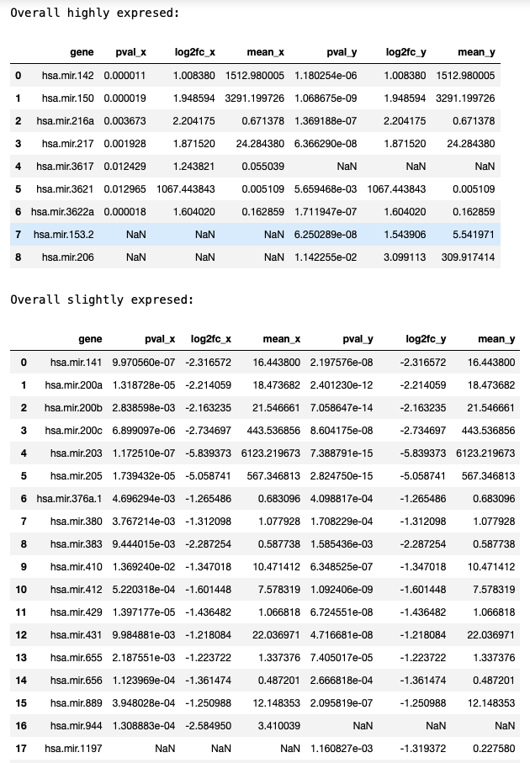

#### local skin metastasis

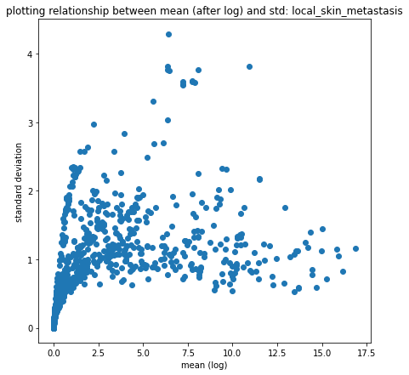

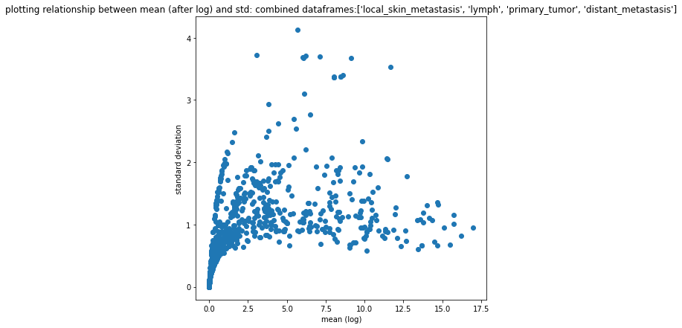

MA plot:

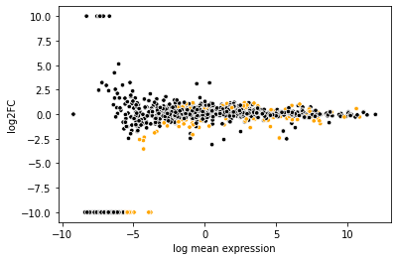

Volcano plot:

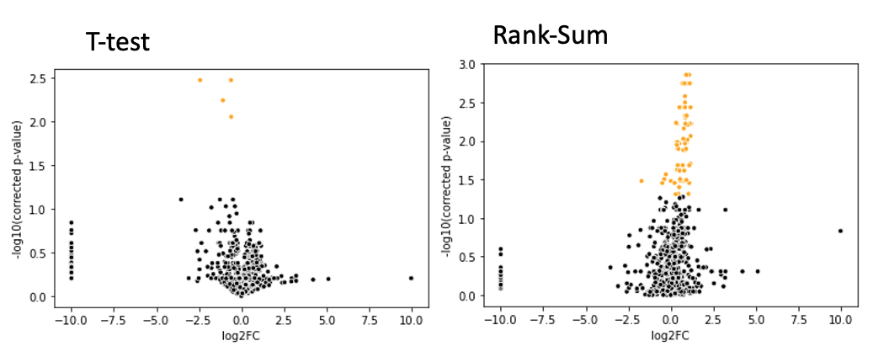

Log10_pval for t-test (x axis) vs log10_pval for rank sum test (y axis)

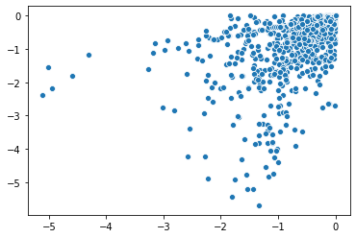

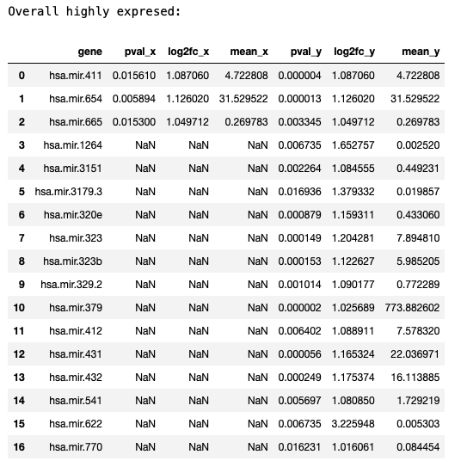

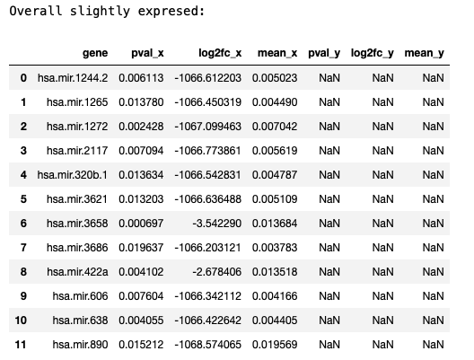

#### distant metastasis

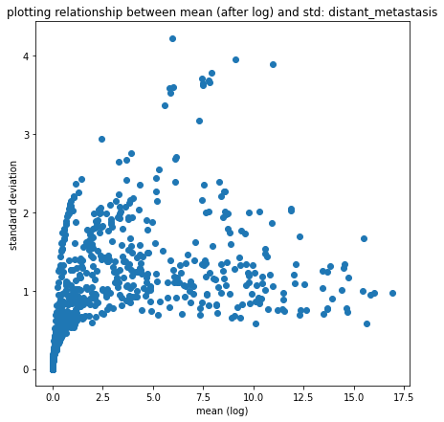

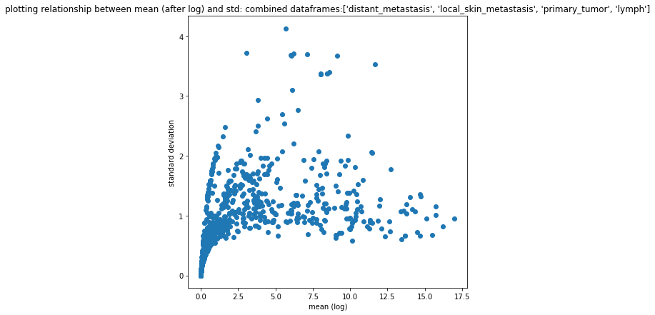

MA plot:

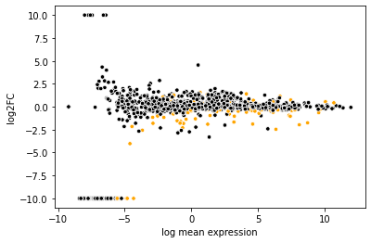

Volcano plot:

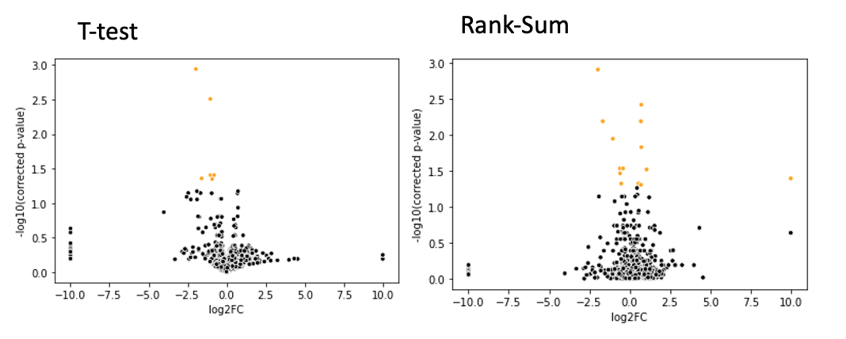

Log10_pval for t-test (x axis) vs log10_pval for rank sum test (y axis)

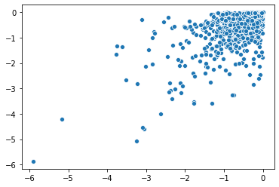

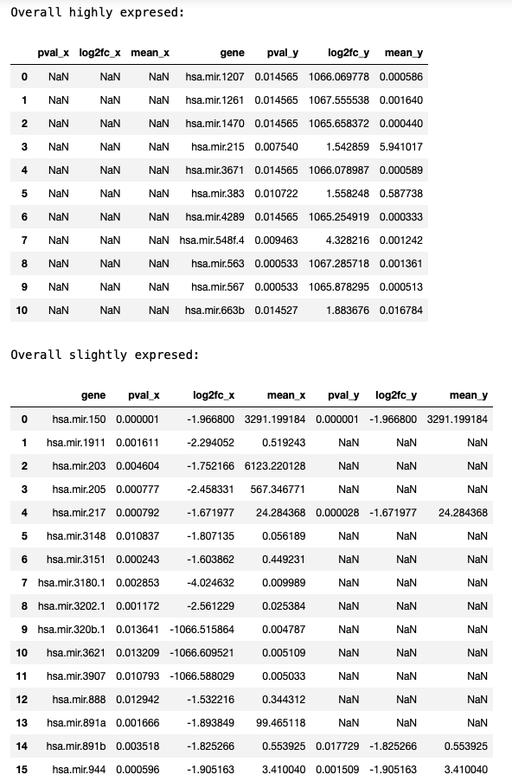

**Finding common slightly expressed genes in primary tumor, local skin metastases, distant metastases, lymph nodes:**

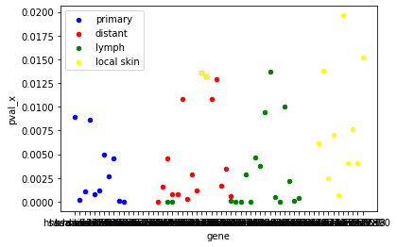

### Conclusion

* When we obtain highly-expressed genes for local skin metastasis vs primary there are no highly expressed gene similarities.
* When we obtain highly-expressed genes for lymph metastasis vs local skin metastasis vs distant tissues in the different methods we devised, there are gene similarities.
* However, if we use the method we created to analyze lymph metastasis vs local skin metastasis vs distant tissues, we find similarities in some of our resulting genes.

## Section 3:

Question

What are the biological roles of the highly expressed genes in the various metastasis?

### Answer

**Genes expression:**

**1. distant metastasis:**

* SLC34A2 - Defects in this gene are a cause of pulmonary alveolar microlithiasis. Three transcript variants encoding two different isoforms have been found for this gene.
* AGR3- This gene is expressed in ciliated airway epithelial cells. This gene is also over expressed in breast, ovarian, and prostrate cancers.

**2. Lymph**

* OR2M1P - Olfactory receptors interact with odorant molecules in the nose, to initiate a neuronal response that triggers the perception of a smell. The olfactory receptor proteins are members of a large family of G-protein-coupled receptors (GPCR) arising from single coding-exon genes.

**3. local skin metastasis**

* KRTAP12 - In the hair cortex, hair keratin intermediate filaments are embedded in an interfilamentous matrix, consisting of hair keratin-associated proteins (KRTAP), which are essential for the formation of a rigid and resistant hair shaft through their extensive disulfide bond cross-linking with abundant cysteine residues of hair keratins.

**4. primary tumor**

* DEFB4A- Defensins form a family of microbicidal and cytotoxic peptides made by neutrophils. Members of the defensin family are highly similar in protein sequence. Beta-defensin 2 is an antibiotic peptide which is locally regulated by inflammation.
* LCE3E - (Late Cornified Envelope 3E) is a Protein Coding gene. Diseases associated with LCE3E include Plantar Wart.

## Section 4:

Question

Which genes have a higher expression in tumors vs healthy skin? Are these genes similar to genes more highly expressed in metastases vs primary tumors?

**Defining highly-expressed genes**

1. **Differential Gene Expression (DGE) Analysis:** (see description in "Methods" section)

* **This analysis is designed to be performed on counts (expression), not normalized data!**
* To determine if a gene has been significantly expressed, we will use in this section:
  + **P-value** < 0.01
  + **log2FoldChange**: +/- 7.5 (the usual boundary is +/-2)
* However, these tests are unfortunately not enough to deal with our data because we received gtex_data already partially normalized

1. **Our Version of Gene Expression Analysis:**

* Why do we need this when we can use DGE analysis?
  + Most methods use a counts matrix that has not been normalized and perform calculations based on it. In the case of TCGA data, we have these counts matrix available. However, gtex data is a dataset we already received partially normalized (genes have a mean of zero). **Tests based on means cannot work for gtex data, because all of our means are zero.**
  + We read that to the actual count numbers in the gene expression dataset and the numbers that are the basis for the gtex dataset are derived by different methods, so one number cannot actually be compared to another directly
* For these reasons, we also defined our own definition of highly-expressed genes, using our normalized datasets:
  + Per gene per dataset, we have a gene expression value per sample, but want to define a single gene expression value to use to represent that gene (so that we can compare all values and find large ones to be highly expressed)
  + We will use **median gene expression** per gene
    - The normalization affects the values, but medians per gene can have a range of values
    - We arbitrarily selected to look at genes with median values in the 99.9th percentile, but defined this as a parameter, and other values can also be examined
    - Per group of samples, we will select the genes with 99.9th percentile of highest median expression as "highly expressed" for that group

### Analysis Description

**Perform Differential Gene Expression (DGE) Analysis for Metastases Samples vs Primary Samples:**

* Prep data for determining highly and slightly expressed genes/miRNA in a given non-normalized dataframe. As part of this process:

1. Divide dataframe into a primary-samples-only dataframe and a metastases-samples-only-dataframe
2. Plot the relationship between mean and std for the full dataframe, primary dataframe, metastases dataframe
3. Transpose full dataframe to get a matrix where samples are rows, dimensions (genes/miRNA) for columns
4. Create a sample types dataset, where the condition is defined as: if metastasis sample: 1, otherwise 0
5. Create an AnnData object that will hold our data matrix (X), sample descriptions, and and labels - and return it

* Perform differential expression analysis

1. Run 2 types of tests on the data: Welch's t-test and rank sum test
2. Display an MA plot (this should be used to help define limits used to limit log2foldchange for high, low expression)
3. Graph volcano plots based on both tests to help differentiate significant values
4. Plot a comparison of both tests
5. Create a dataset of highly expressed genes/miRNAs and slightly expressed genes/miRNAs using pvalue=0.01, log2foldchange: lower than -7.5 for slightly expressed, higher than 7.5 for highly expressed
6. merge all highly expressed genes into one dataframe, slightly expressed genes into one dataframe
7. return highly expressed and slightly expressed dataframes

### Relevant Visualizations Part 1

* Graphing relationship between dataframe mean and std (after log2): for total gene expression data, for primary samples only, and for metastases samples only

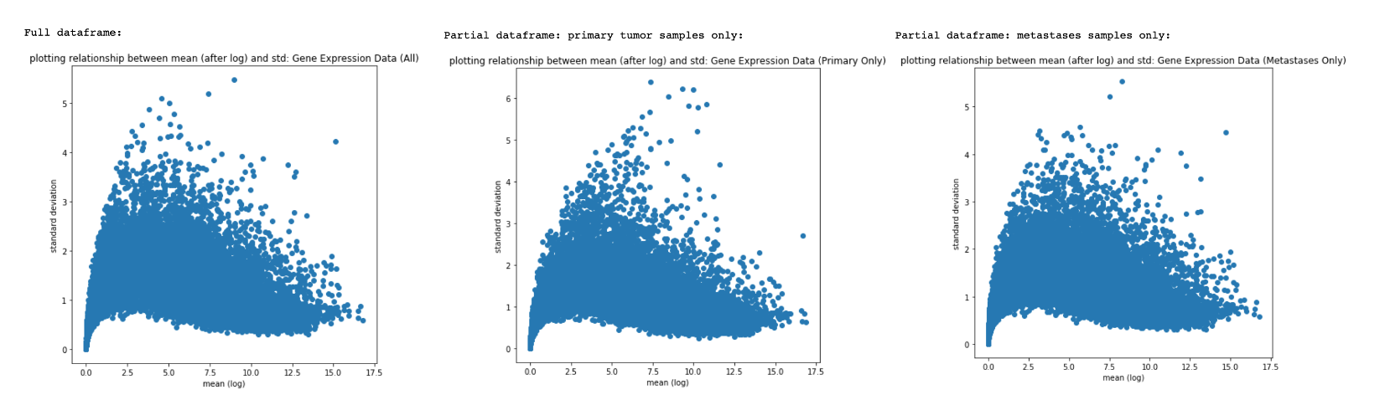

* MA Plot:

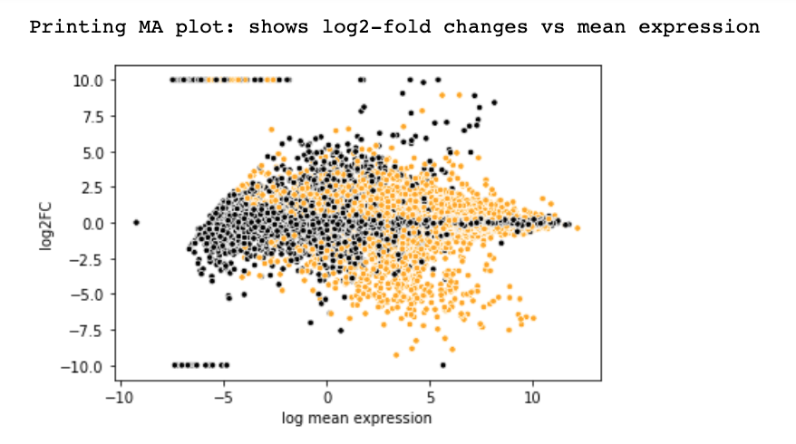

* Volcano Plot

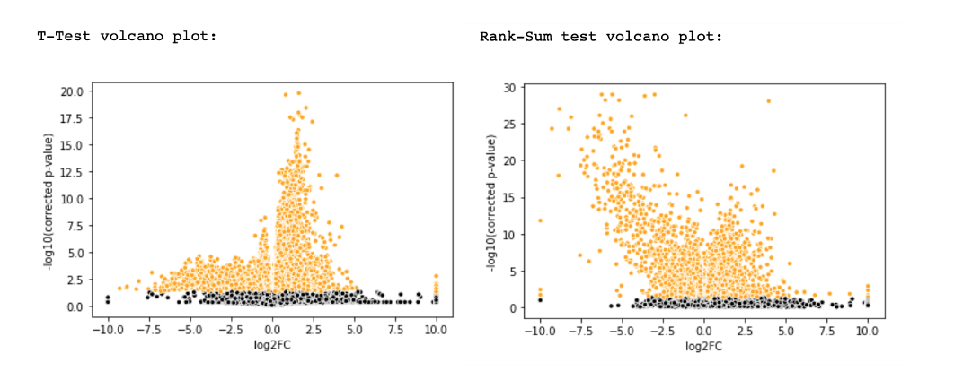

* Graphing t-test results vs rank-sum results

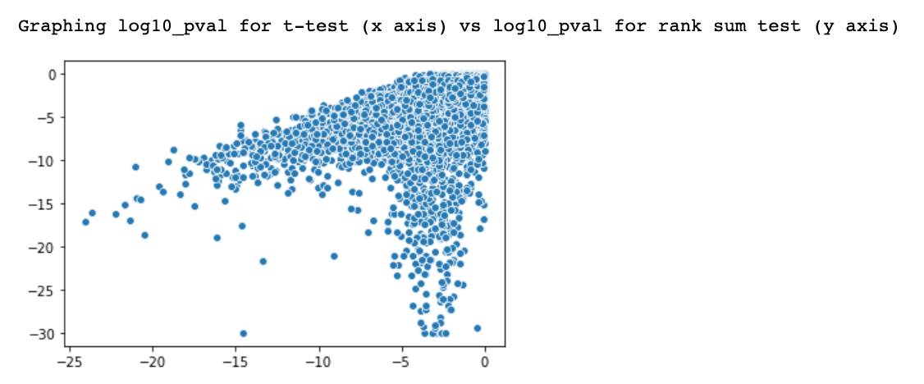

* overall highly expressed genes (metastasis vs primary tumor): (x columns are for the t-test results, y columns are for the rank-sum results):

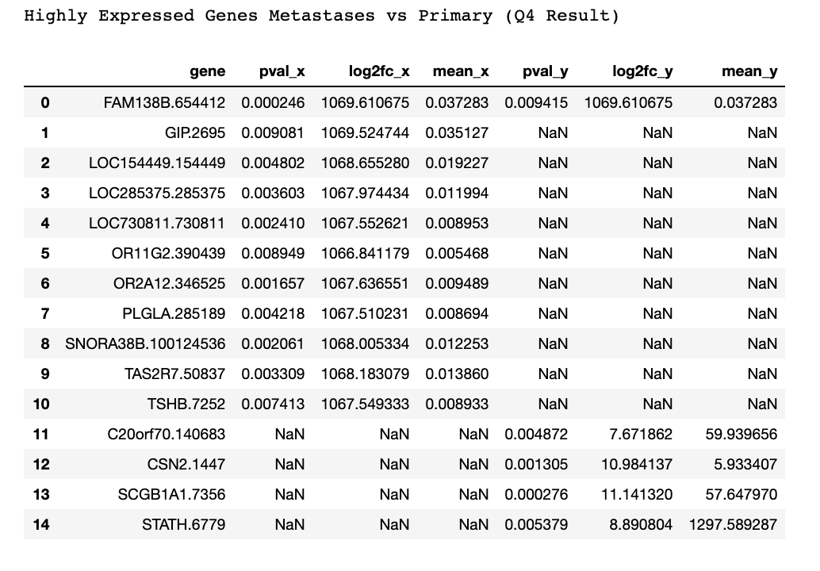

**Prep GTEX Data for Analysis**

* We had to match ensemble_ids in the gtex_data dataset, that contains healthy people skin samples, to 'genes' in the gene_data dataset

1. We researched the various types of gene IDs that exist, in order to understand which IDs we are actually looking at and need to translate between, because there are numerous gene id versions. According to our research:
   1. our gtex dataset uses enemble_ids, also referred to as: "gene stable id"
   2. our gene expression dataset uses a combination of "gene name" and "NCBI gene id", separated by a period
2. We searched for methods for converting between these genes ids, and found several options:

* packages available only in R
* an online conversion interface, <http://www.ensembl.org/biomart/martview/>
* an online conversion interface, <https://mygene.info/demo> (we used it, but it had many missing translations)

1. Eventually we managed to convert the most IDs using http://www.ensembl.org/biomart/martview/, so we selected that method, with the following parameters:

* FILTERS:
  + GENE: Input external references ID list [Max 500 advised]: "Gene stable ID(s)
* ATTRIBUTES:
  + GENE: Ensembl: "Gene stable ID", "Gene name"
  + EXTERNAL: External References: NCBI Gene ID

1. Dealing with interface limitations: the interface can translate a maximum of 500 gene IDs at a time, therefore we divided the ensemble_ids in gtex_data into sub-datasets of 500 ids or less

* gtex_data contains 16593 ensemble_ids, so the dataset had to be divided int 34 datasets
* each file was uploaded to the interface, and the results were saved in 34 text files called "mart_export (#).txt"
* the 34 result text files were combined into a single conversions dataset
* a gene column was added to the conversions dataset, created using: "gene name"."NCBI gene id" where "NCBI gene id" was available, and "gene name" only where it was not available.

1. The new conversions 'gene' column was merged into the gtex_data dataset
2. Gtex_data was merged with the 'gene' column of gene_data, to examine the genes that could be matched

* it is important to note that gene_data contains only genes that have high variance, because we removed all genes that had low variance values as part of the normalization and data cleaning process

1. Only matched genes (a total of 5181 genes) were left in the gtex dataset

**Our Version of Gene Expression Analysis**

* Finding most highly expressed genes in metastases vs primary samples:
  + We divided the gene expression dataset into a primary tumor dataset (01 samples) and a metastases dataset (06 samples)
  + We calculated the median value per gene (according to all samples in the group)
  + We graphed the median gene expression by sample type (primary/metastasis) to help select a cutoff line
  + We defined a cutoff line at gene expression medians in the 99.9 percentile (this percentile was arbitrarily selected, based on graphing, but it is a parameter that can be changed in the analysis)
  + We created a dataset for 01 samples and 06 samples that contains only genes with median values equal or greater than the 99.9th percentile value, and combined these results into one single dataset (highly_expressed_06_vs_01)

* compare to healthy skin to tumor sample
  + We could not directly compare gene expression values in gene_data to the numbers in the gtex_data dataset, even for matching genes, because according to our research, the numbers are obtained through different processes before they are normalized
  + Per dataset (gtex_data, gene_data (all samples, 01 and 06 combined)) we calculated the median value per gene according to all relevant samples
  + We defined a cutoff line at medians in the 99.9 percentile
  + We created a dataset for gtex samples and tumor samples that contains only genes with median values equal or greater than the 99.9th percentile value, and combined these results into one single dataset (highly_expressed_gtex_vs_cancer)
* We created a combined dataset for highly-expressed genes in all datasets: highly_expressed_comparison (by combining highly_expressed_gtex_vs_cancer and highly_expressed_06_vs_01), and also graphed the dataset. <br />

### Relevant Visualizations Part 2

* Finding the our version of highly-expressed genes in healthy skin and highly-expressed genes in tumors (primary and metastases) - for each dataset, these are genes with a median value in the 99.9th percentile of median values.

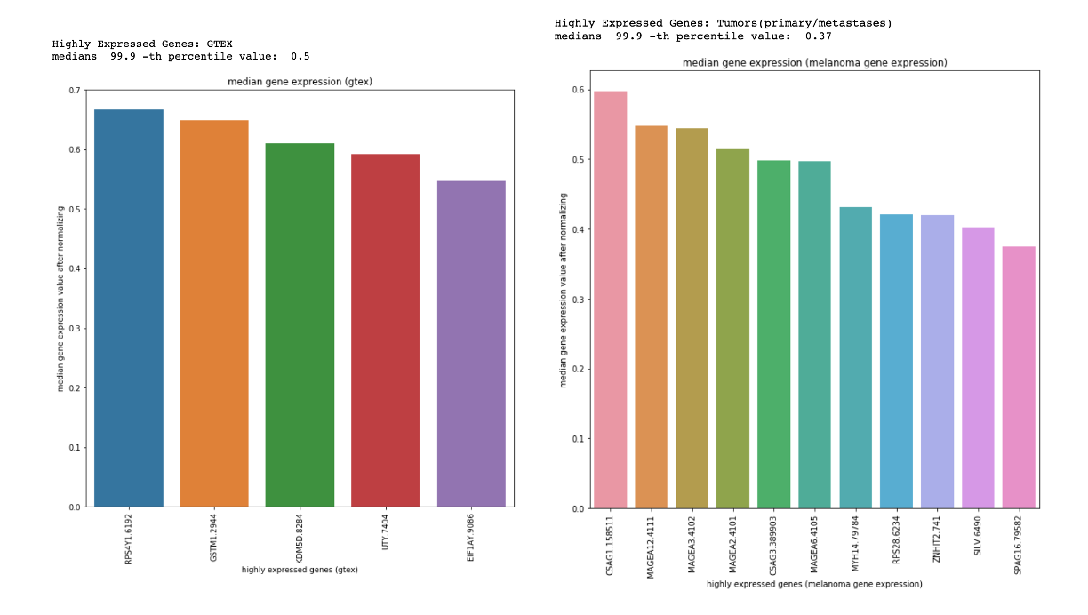

* The resulting genes:

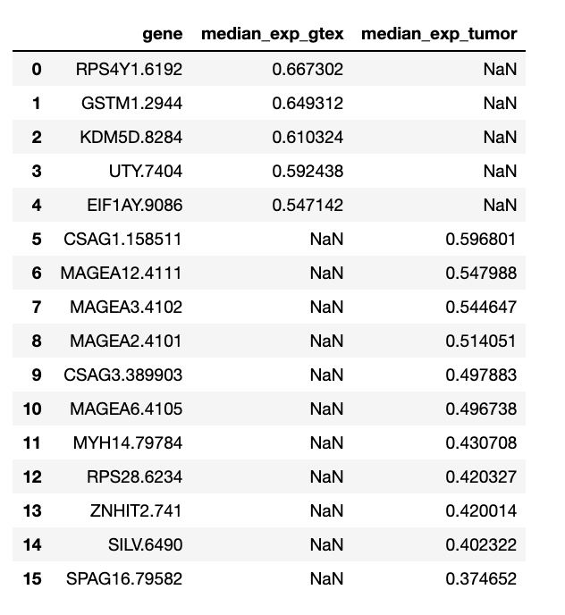

* If we compare these genes to genes found as highly-expressed for metastases vs primary found using differential gene expression analysis, we find no genes in common!
* Instead, we will attempt to use our method for metastases and primary genes also. Finding the our version of highly-expressed genes in metastasis and highly-expressed genes in primary tumors - for each dataset, these are genes with a median value in the 99.9th percentile of median values:

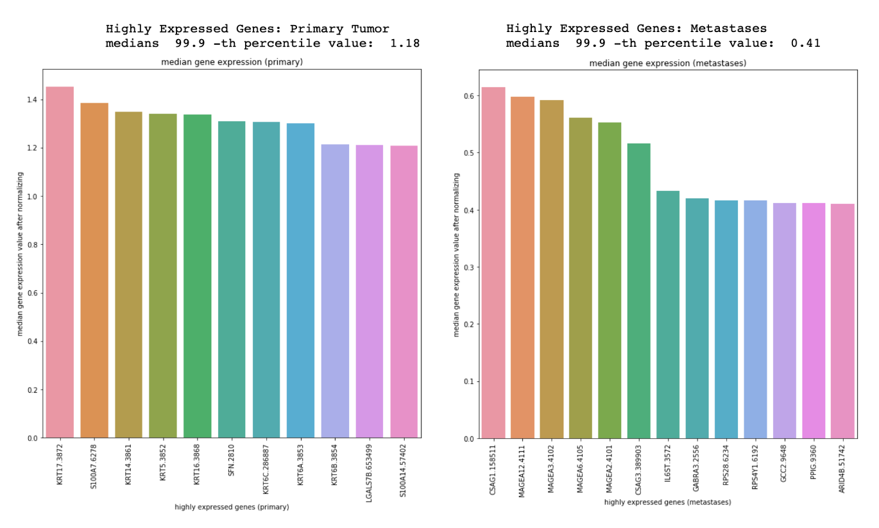

* Using this method we can see that some genes we considered highly-expressed in tumors in general are also highly-expressed in metastases, and one genes we consider highly expressed in healthy skin is also highly expressed in metastases:

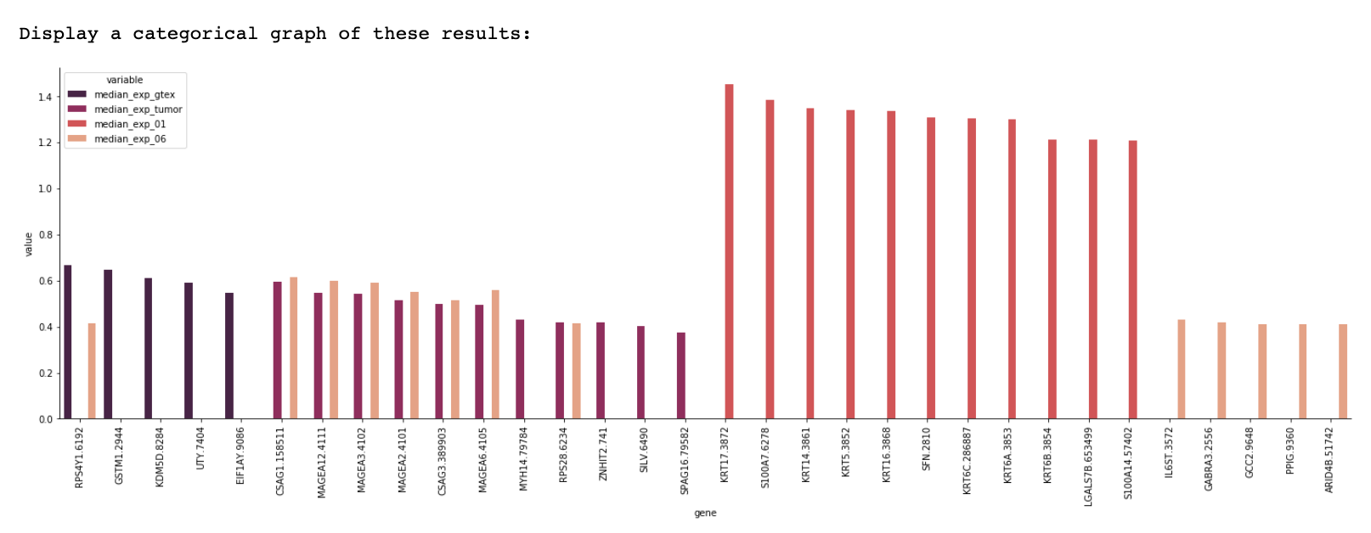

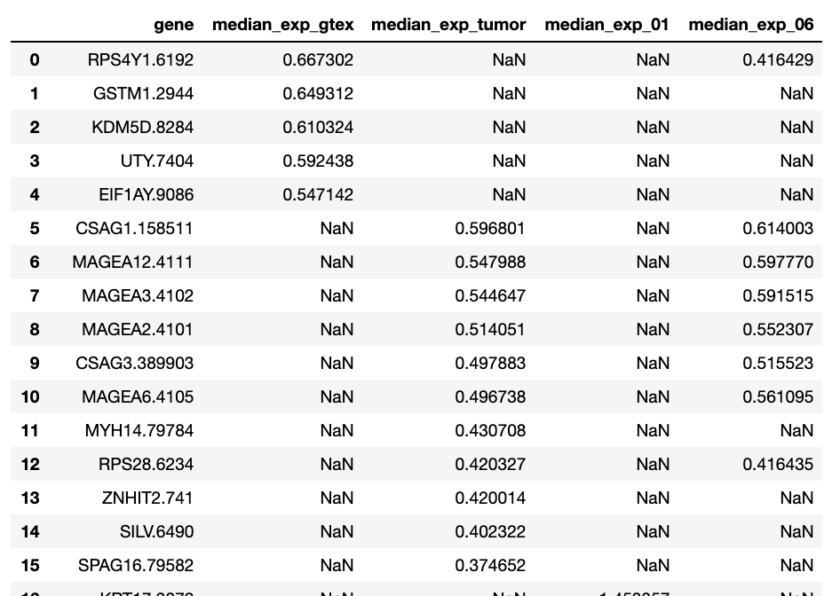

### Conclusion

* Unfortunately, we could not use only differential gene expression analysis to get results for this question because the gtex data we received is already with zero means.
* When we obtain highly-expressed genes for metastases vs primary with DGE and highly-expressed genes for cancer vs healthy skin in the different method we devised, there are no gene similarities.
* However, if we use the method we created to analyze both cancer vs healthy skin and metastasis vs primary, we find similarities in some of our resulting genes:
  + We see that out of 11 genes that have a high expression in tumors, 7 (64%) are also highly expressed in metastases. These genes are: CSAG1.158511, MAGEA12.4111, MAGEA3.4102, MAGEA2.4101, CSAG3.389903, MAGEA6.4105, RPS28.6234
  + We see that out of 5 highly expressed genes in healthy skin, 1 gene (20%) is also highly expressed in metastases: RPS4Y1.6192

## Section 5:

Question

There are miRNAs for which we know what genes expressions they affect. Are miRNAs that act differently between primary tumors and metastases known to be responsible for genes expressed differently between primary tumors and metastases? To answer this question, we should use external DBs that map known relationships between miRNA and genes, such as http://www.mirdb.org/faq.html

### Analysis Description

1. Perform differential expression analysis for non-normalized micro RNA data, and return highly and slightly expressed gene lists (using functions defined in Q4)
2. Display results from highly/slightly_expressed_genes_06_vs_01 found in Q4, vs results for micro_rna
3. Check http://www.mirdb.org/faq.html to determine:
   1. if highly expressed genes are known to be related to highly expressed mRNA
   2. if slightly expressed genes are known to be related to slightly expressed mRNA
4. Section 3 should be done by searching for relevant gene symbol, and then relevant gene NCBI ids in the db. One of these is not enough because in some cases there is a mis-match in the TCGA gene id format

### Visualizations

* Graphing relationship between dataframe mean and std (after log2): for total micro RNA data, for primary samples only, and for metastases samples only:

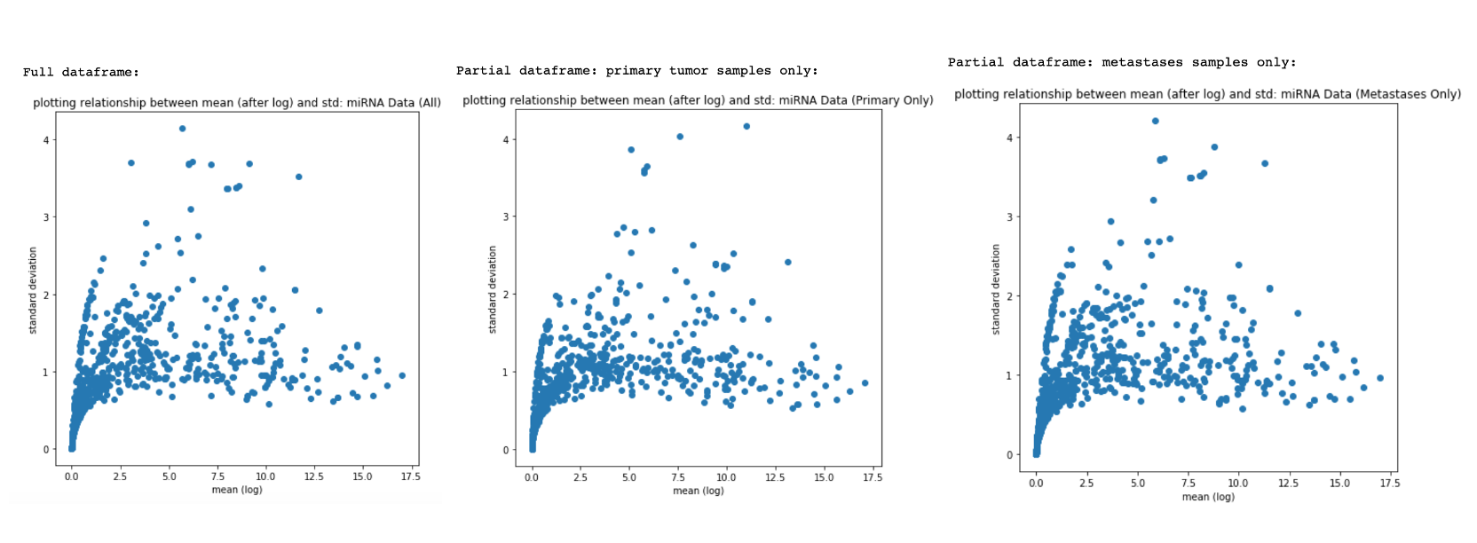

* MA Plot

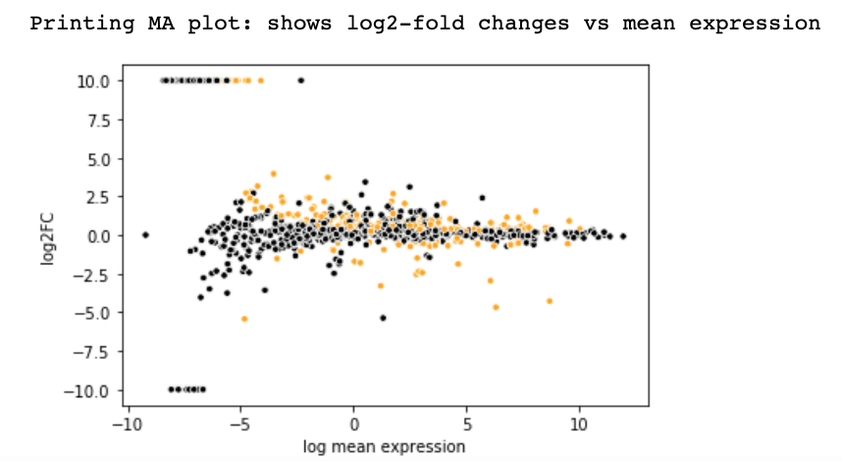

* Volcano Plot

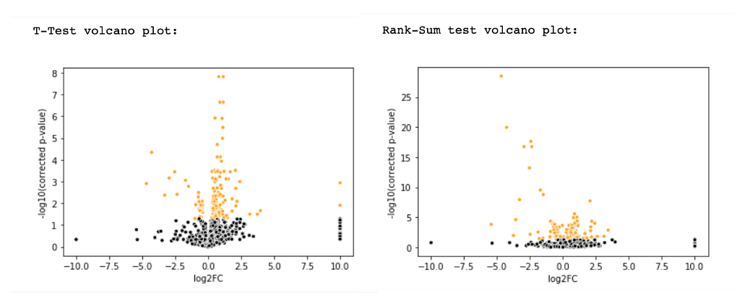

* Graphing t-test results vs rank-sum results

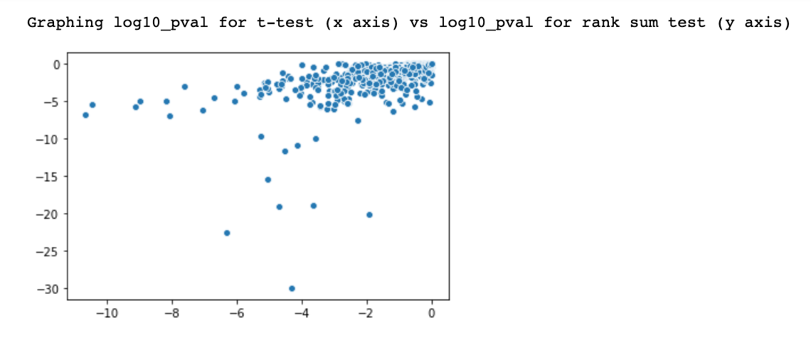

* Display overall highly expressed mRNA (metastasis vs primary tumor): (x columns are for the t-test results, y columns are for the rank-sum results) next to overall highly expressed genes found in Q4: [x are t-test results, y are rank-sum results]

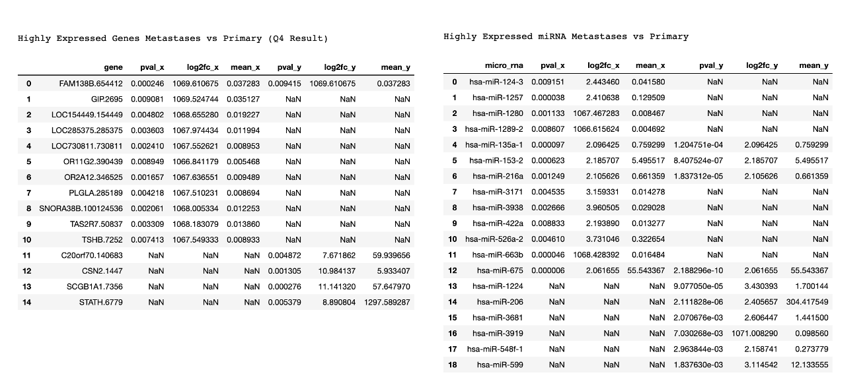

* Relationships found in mirdb between highly-expressed genes and miRNAs (only for genes actually found in the db)

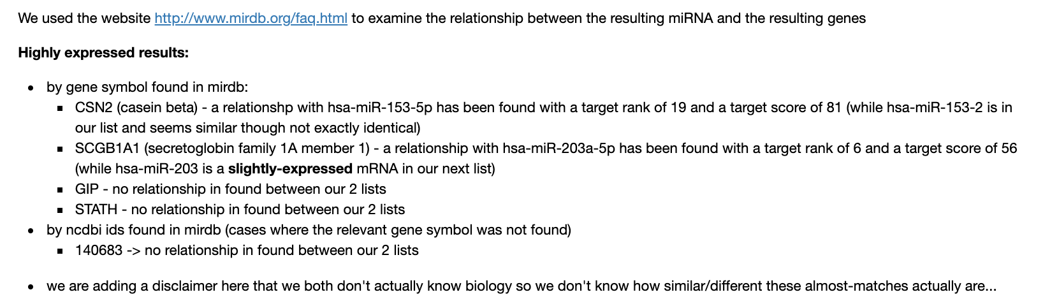

* Display overall slightly expressed mRNA (metastasis vs primary tumor): (x columns are for the t-test results, y columns are for the rank-sum results) next to overall slightly expressed genes found in Q4:

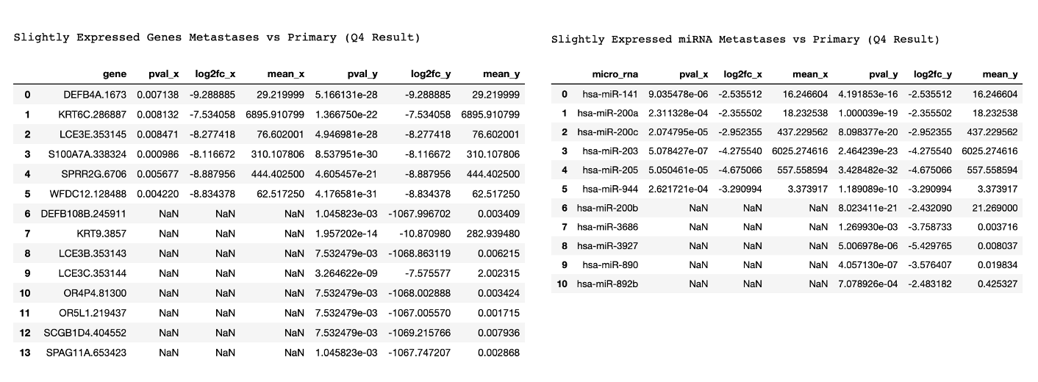

* Relationships found in mirdb between slightly-expressed genes and miRNAs (only for genes actually found in the db)

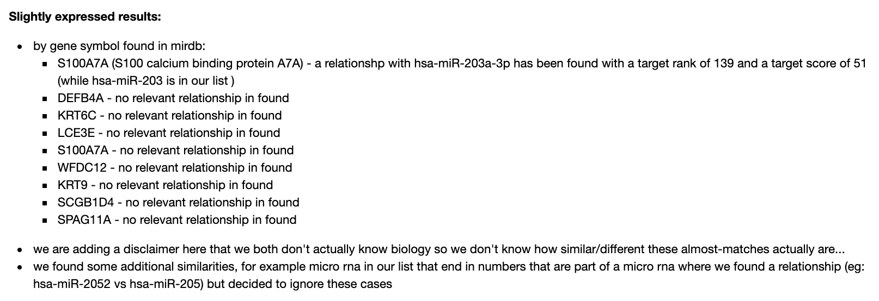

### Conclusion

* We found very few relevant relationships:
  + The only known relationship found between highly expressed genes and highly expressed mRNA was between CSN2 and hsa-miR-153-5p (while hsa-miR-153-2 was in our list). We found an additional relationship between a highly-expressed gene and a slightly-expressed miRNA: SCGB1A1 and hsa-miR-203a-5p (while hsa-miR-203 was a slightly-expressed miRNA in our list).
  + The only known relationship found between slightly expressed genes and slightly expressed mRNA was between S100A7A and hsa-miR-203a-3p (while hsa-miR-203 was in our list)
* We can point to several possible explanations:
  + We defined "highly/slightly" expressed genes/miRNA using arbitrary choices for pvalues/logfoldchanges that we selected based on MA plots and in order not to get **many** results, in our opinion. Changing these arbitrary limits would have resulted in far more highly/slightly expressed results, and thus might have increased the number of relationships we would have found
  + Not all genes in our results were found mapped in mirdb. This could be because they have no known mapping, and could also be a result of a mix-up in gene id formatting. While most gene names in the TCGA dataset are formatted by placing "gene name/symbol"."NCBI gene id", we have found several genes that seem to have different formats. Many genes we searched for were missing, and maybe this has to do with name formatting
  + We both don't know biology, so had a difficulty in understanding how miRNA/genes we found with similar names to miRNA/genes in our list are actually similar...

## Section 6:

Question

Among the genes and miRNA that are highly expressed in metastases vs primary tumors, are there genes/miRNA that affect the prognosis of the patient?

### Analysis Description

1. We performed differential expression analysis for genes and micro RNA using the patient's prognosis as a condition (instead of the sample type we used previously).
   1. For genes: we used pvalue=0.01 and logfoldchange greater than 2 or less than -2
   2. For miRNA: we used pvalue=0.05 and logfoldchange greater than 2 or less than -2
2. To do this, we used the isDead column of dataframes['survival_data']: if died, 1, else 0.

* to do this we edited a version of the create_data_to_find_highly_and_slightly_expressed to create a relevant AnnData object slightly differently from the previous questions
* we realize this is a slightly problematic way to look at our data, because it doesn't take into account the number of days the patient was actually a part of the study before dying, however it is the best idea we came up with to tackle this question

1. We compared the resulting highly/slightly expressed genes and miRNA lists to results found for metastases vs primary tumors.

### Visualizations

1. **for genes:**

* MA Plot

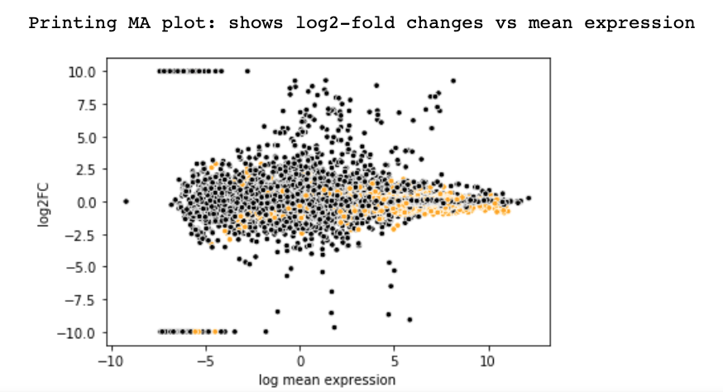

* Volcano Plot

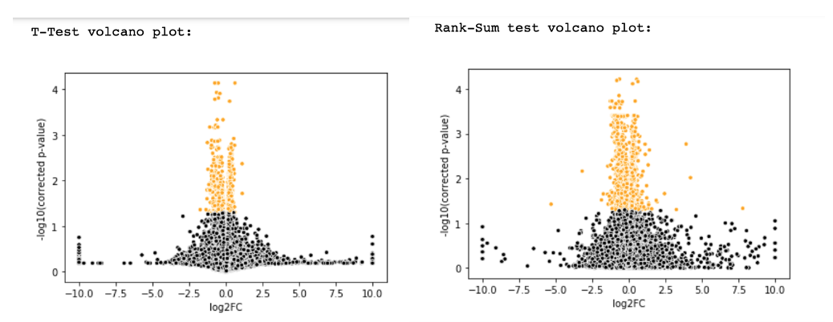

* Graphing t-test results vs rank-sum results

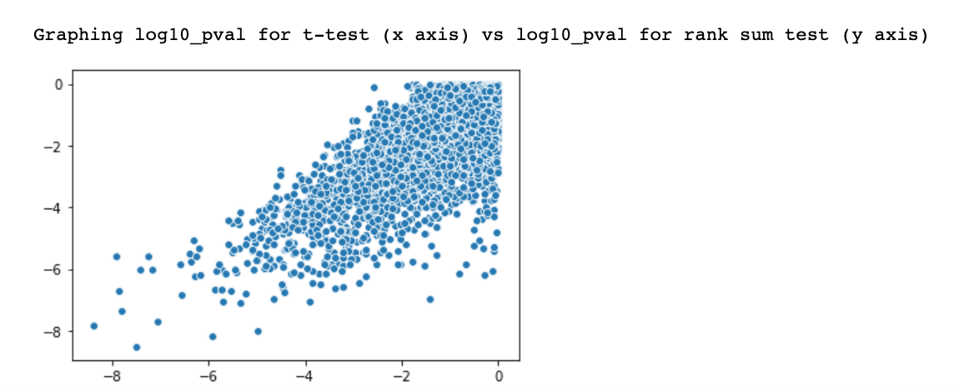

* Display overall highly expressed genes/slightly expressed genes by prognosis: none of these genes were found as highly or slightly expressed for metastasis vs primary tumor

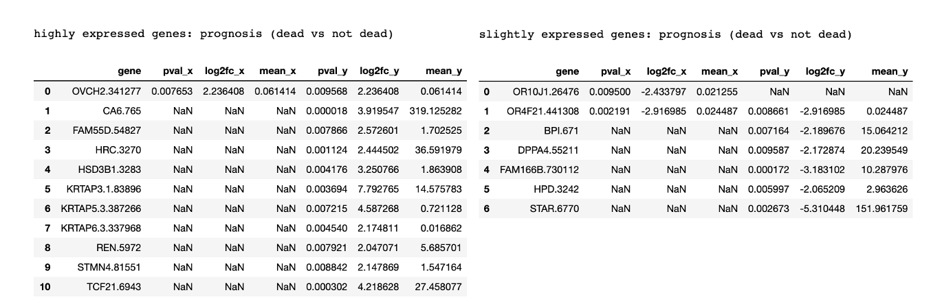

1. **for miRNA:**

* MA Plot

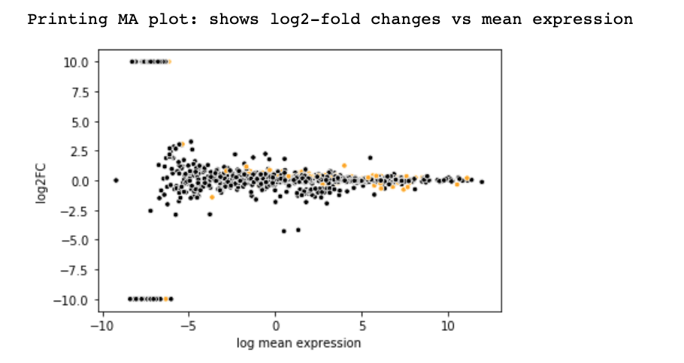

* Volcano Plot

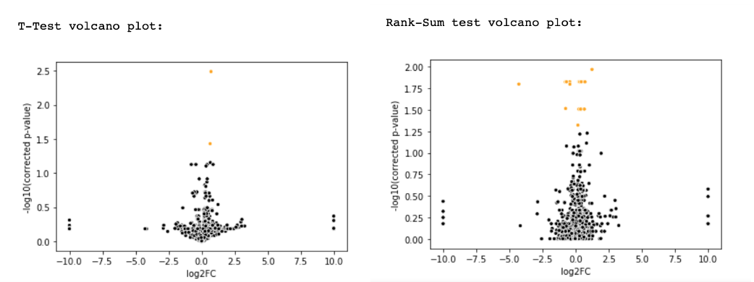

* Graphing t-test results vs rank-sum results

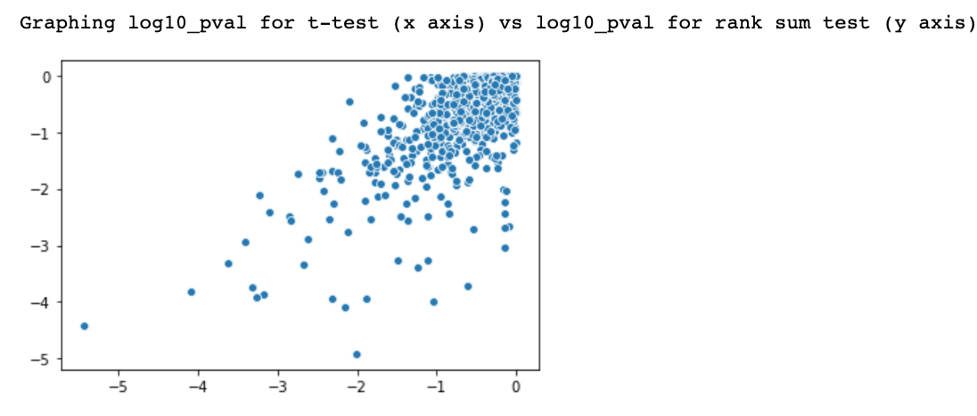

* Display overall highly expressed genes/slightly expressed genes by prognosis

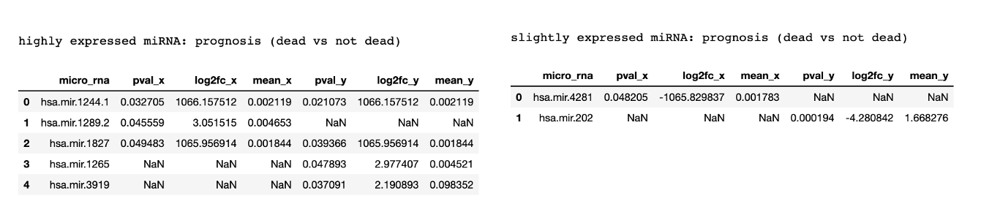

* Of these highly expressed miRNAs, 2 were also highly expressed for the metastases vs primary analysis:



### Conclusion

* We found two miRNAs that were highly expressed for the metastases vs primary analysis and also highly/slightly expressed for the analysis by prognosis:
  + mRNA hsa.mir.1289.2
  + mRNA hsa.mir.3919
* We found no genes that were highly expressed for the metastases vs primary analysis and also highly/slightly expressed for the analysis by prognosis

## Section 7:

Question

It is possible that highly-expressed genes for metastases will be related to the immune system, because the tumor may be larger and therefore the immune system may attack it more. Try removing such genes from your analysis

### Analysis Description

1. First we tried to determine which genes are related to the immune system.

* We did this by downloading the data in https://www.immport.org/shared/ (based on an explanation we found in https://www.innatedb.com/redirect.do?go=resourcesGeneLists) into dataframes['immune_genes']

1. We created a new non-normalized dataframe that contains only genes that are not related to the immune system, and called it: not_normalized_dataframes['gene_data_without_immune']
2. We preformed differential gene expression analysis using the functions defined in Q4 on the data without immune cells

### Visualisations

* Graphing relationship between dataframe mean and std (after log2):

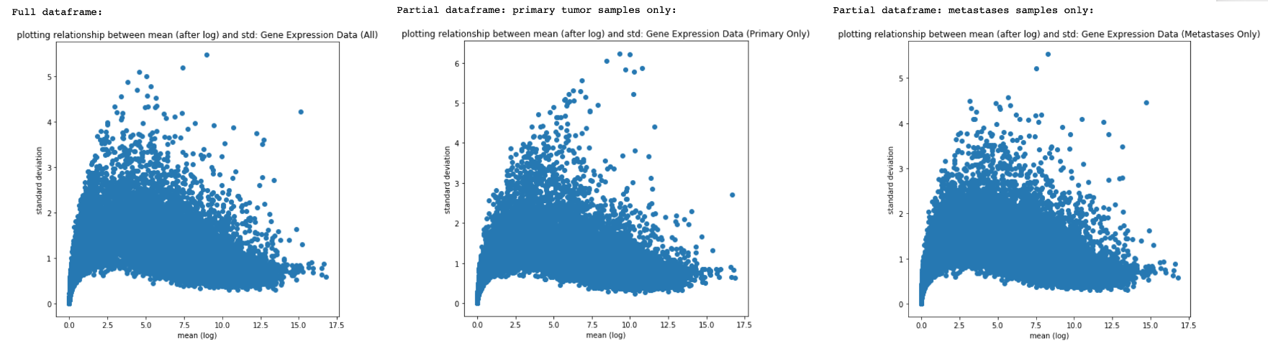

* MA Plot

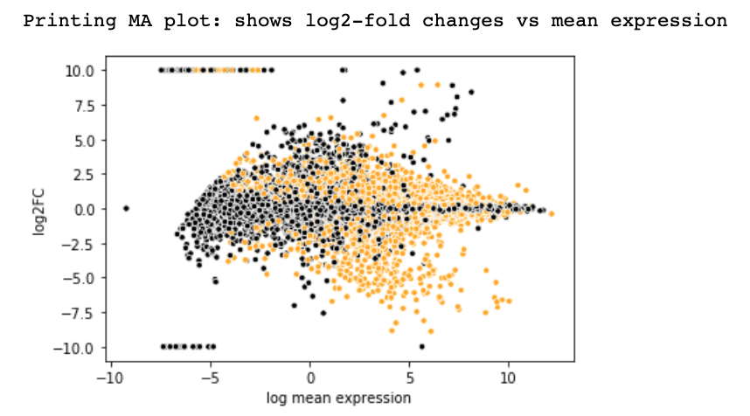

* Volcano Plot

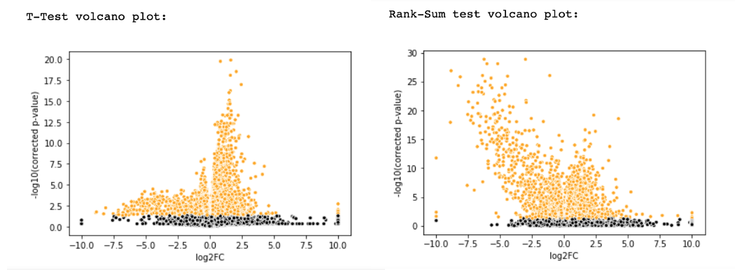

* Graphing t-test results vs rank-sum results

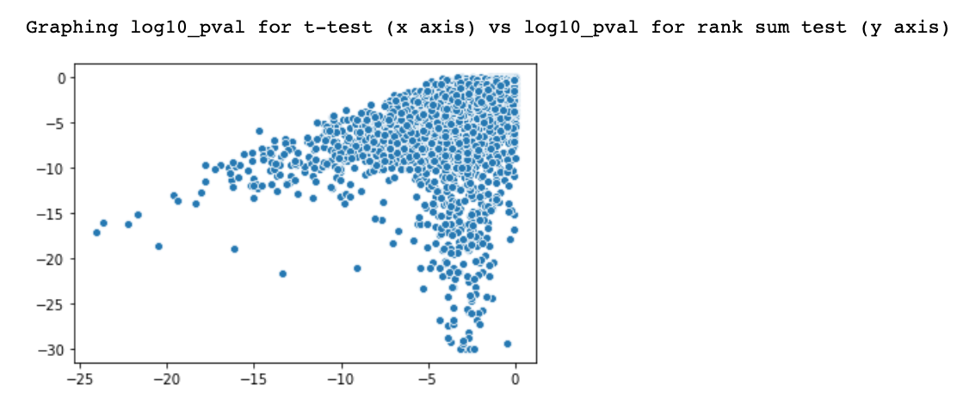

* Display overall highly expressed genes/slightly expressed genes (only genes not related to the immune system): the results are the same as our original results except for 3 missing genes

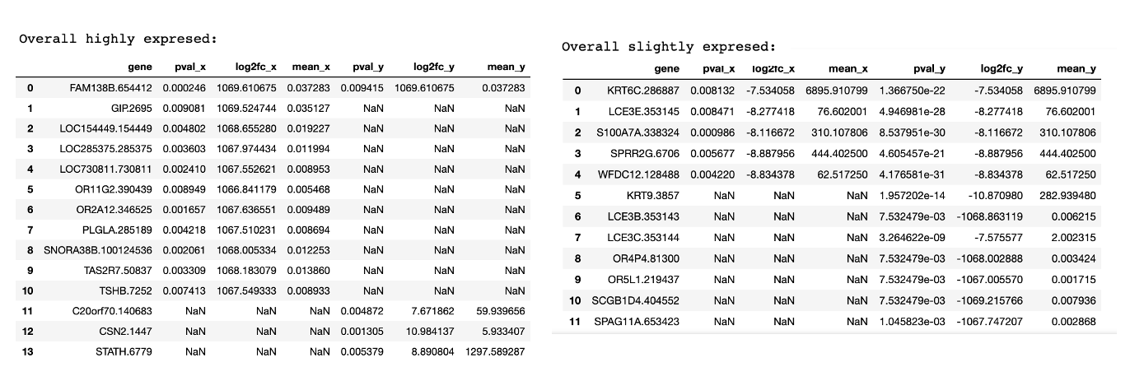

* missing genes:

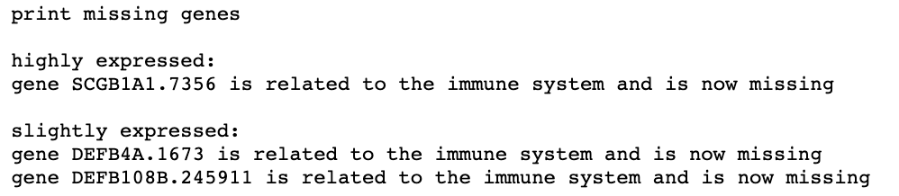

### Conclusion

* The results contain the same genes as our original analysis, except some of the original genes are missing (specifically: SCGB1A1.7356 is missing from the highly-expressed list and DEFB4A.1673, DEFB108B.245911 are missing from the slightly-expressed list)
* There is no bigger change in our results because we didn't change the limits for the log2foldchange (which we originally selected based on the MA plot) or the pvalue: by keeping them the same as before, we did not leave any major room for change in the data except for having some genes missing from our new list